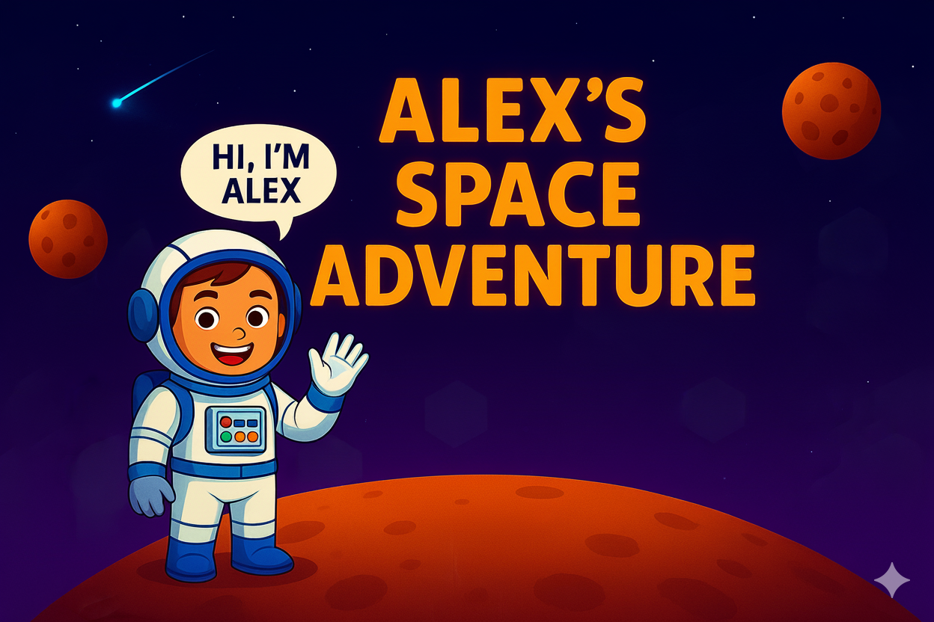

ArcademIa Developers Manual

Group Manager: Melanie Kruger

Contents

1.Introduction 7

2.Tool 7

2.1 DEVELOPER ENVIRONMENT: GODOT 7

2.1.1 Core Principles 8

2.1.2 Advantages of using Godot 8

2.2 PROGRAMMING LANGUAGE: GDSCRIPT 9

2.2.1 Core Features 9

2.2.2Advantages of GDScript over C# or C++ in Game Development 9

Benefits of utilizing GDScript as the main programming language (especially in the case of this project): 10

3. SETUPS 10

3.1 DEVELOPER ENVIRONMENT: GODOT 10

3.2 Godot Workspace Introduction 12

3.2.1 Main Menu Bar: 13

3.2.2 Menus 13

3.2.3 Main Workspace Tabs 14

3.2.4 Scene/Game Play Buttons 14

3.2.5 Scene Dock 15

3.2.6 FileSystem Dock 16

3.2.7 In this Game 17

3.2.8 2D/3D Viewport 18

3.2.9 Inspector Dock 19

4.2.10 Node Dock 19

4. DATABASE: 20

5. Input Mapping and Key binds 21

5.1 HTML Level 1 – 4 21

5.2Mapping In JoyToKey 22

5.3 The Joystick 22

5.4 The Other Buttons on The Arcade Machine 22

5.5 Mapping Of Buttons in Godot 22

5.5.1 Back Button 22

23

5.6 Other Buttons 24

6. Coding Explained: 25

6.1 Start Screen 25

6.1.1 Class: Start Button Script 25

6.1.2 Function: _on_start_button_1_pressed 25

6.2 Student Teacher Screen 25

6.2.1 Class: Scene Transition Script 25

6.2.2 Function: _on_student_button_pressed 25

6.2.3 Function: _on_teacher_button_pressed 26

6.2.4 Function: _process 26

6.2.5 Function: _on_back_button_pressed 26

6.3 Avatar Creation 27

6..3.1 Class Declaration 27

6.3.2 Variable Declarations-Texture Arrays 27

6.3.3 Variable Declarations -Current Indices 27

6.3.4 Variable Declarations-Backup Variables 27

6.3.5 Node References- Avatar 28

6.3.6 Node References- Save Button 28

6.3.7 Node References- Value Label Dictionary 28

6.3.8 Node References- Previous Button Dictionary 28

6.3.9 Node References-Next Button Dictionary 29

6.3.10 Function: _ready() 29

6.3.11 Loading Required Textures 29

6.3.12 Loading optional Textures 29

6.3.13 Connecting Button Signal 30

6.3.14 Connecting Save Button 30

6.3.15 Initial Updates 30

6.3.16 Function: load_textures 31

6.3.17 Function: _name() 31

6.3.17 Function: _update_all_labels 32

6.3.18 Function: Update-Avatar 32

6.3 19 Function: cycle-texture 34

6.3.20 Function: _center_avatar_and_scale 35

6.3.21 Function: _set_disabled_state_for_fullsuit 36

6.3.22 Function: _process 36

6.3.23 Function: _on_back_button_pressed 37

6.3.24 Function: _on_save_pressed 37

6.4 Student Login 37

6.4.1 Class Declaration 37

6.4.2 Variable Declarations and Initializations 38

6.4.3 Function: _ready()-Password should not show 38

Function: _on_eye_pressed() 40

Function: save_button_pressed 40

Function: _on_save_button_pressed() 41

Function: _process 43

Function: _on_back_button_pressed 43

Login Teachers 43

Class: Main Scene Script 43

Function: _ready 44

Function: _add_password_eye_toggle 44

Function: _on_eye_pressed 45

Function: _on_save_button_pressed 45

Function: _on_save_button_2_pressed 46

Function: load_students 48

Function: _process 48

Function: _on_back_button_pressed 48

Signup Teachers 49

Class: Main Scene Script 49

Nodes 49

Constants 49

Variables 49

Function: _ready 50

Function: _add_eye_toggle 50

Function: _on_save_button_pressed 51

Inline Error Helpers 53

Function: _is_five_digit_pin 53

Data Helpers 54

Function: _process 55

Function: _on_back_button_pressed 56

Student Signup 56

Class: Main Scene Script 56

Nodes 56

Constants 56

Variables 56

Function: _ready 57

Function: _add_password_eye_toggle 57

Function: _on_eye_pressed 58

Function: _on_save_button_pressed 59

Inline Error Helpers 59

Function: _is_five_digit_pin 60

Data Helpers 60

Function: _process 61

Function: _on_back_button_pressed 61

The Game 62

Block.gd 62

Class: Blocks Script 62

Nodes 62

Variables 63

Function: _ready 63

Function: _process 64

Function: go_back 64

Function: load_game 65

Function: reload_level 65

Function: _on_web_view_ipc_message 66

Function: _run_program 66

Function: _execute_command 67

Function: _evaluate_condition 70

Function: _move_player 70

Function: _spaceship_part_exists 71

Function: _find_spaceship_part 71

Function: _count_blocks 72

Coin.gd 72

Class: Spaceship Part Script 72

Nodes 72

Variables 73

Function: _ready 73

Function: _on_body_entered 73

Function: _go_to_outro 74

Function: save_player_progress 75

Function: load_students 76

Function: save_students 76

Player.gd 77

Class: Player Character Script 77

Constants 77

Nodes 77

Variables 77

Function: _play_step_sound 78

Function: _on_step_sound_finished 78

Blockly API Functions 79

Physics Process Function 80

Blockly Movement Handler 81

Animation Function 81

Ground and Wall Detection 82

Globals.gd 82

Class: Globals Script 82

Variables 82

Onready Variables 83

Function: set_current_user 83

Function: get_current_user 83

Function: _update_scores_from_user 84

Main Menu 84

Class: Level Selection Menu Script 84

Nodes 85

Function: _ready 85

Function: load_labels 86

Level Button Functions 86

Exit and Sign-Out Functions 87

Student Management 88

Class: Level Selection Menu Script 88

Nodes 88

Function: _ready 89

Function: load_labels 89

Level Button Functions 90

Exit and Sign-Out Functions 91

Audio.gd 91

Class: AudioManager Script 91

Sound Effects 92

Background Music 92

Variables 92

Function: _ready 93

Function: play_sound 94

Function: _on_sound_finished 94

Function: play_music 95

Function: stop_music 95

Function: _on_scene_changed 96

Function: _reset_track_queue 96

Function: get_random_level_track 96

# 1.Introduction

South Africa urgently needs to improve digital literacy and coding education in schools to prepare learners for future careers. Model C schools have good infrastructure but lack engaging, curriculum-integrated digital tools. This limits students’ readiness for science, technology, engineering, and mathematics (STEM) careers, which are vital for national growth. The Department of Basic Education (DBE) has started rolling out coding and robotics in early grades to better prepare for the coming generations. Despite these initiatives and their potential, they are mostly rooted in traditional forms of learning. In a time when a lot of school children have access to technology, the teaching approach should stay abreast of such changes.

Traditional methods of studying, important as they are, tend to ostracize large percentages of learners who value a different approach to learning. This divide between providing essential skills whilst keeping the interest of the young target market at heart is how the Arcademia a Portable Programming Arcade Console came about. Arcademia is a game-based STEM learning platform built with open-source tools like Godot and GDScript designed to teach Grade 5 kids how to code . It runs on an HP Elite Desk with the used of joystick and buttons and supports curriculum-aligned content through interactive gameplay. The project serves as a platform for young, inquisitive minds to explore the fundamental concepts of programming. Its arcade console is used to make learning fun and engaging.

**This manual serves the following purposes:**

* The manual will help teachers understand the game better by providing a step-by-step description of the software.
* It aims to increase their familiarity with the app's features, allowing them to effectively support their students when using the Arcade Console.

# 2.Tool

## 2.1 DEVELOPER ENVIRONMENT: GODOT

## 



Godot is a cross-platform, free and open-source game engine. It is designed to support 2D and 3D game creation for PC, mobile, as web platforms. 2D as well as 3D game creation enabled by Godot.

Its use of high-level, object-oriented programming languages allows for classes that can be created through node types in order to create more specialized node types that inherit behaviour.  Nodes are organized in instantiable, inheritable, & nestable groups of nodes called “scenes”. Data transmissions are carried out via signals which connect nodes. All game resources are stored locally; this serves as a facilitator for collaboration amongst game developments teams using software version control systems.

### 2.1.1 Core Principles

**Scene and Node System:**

* Every element in Godot from a sprite to a physics body is a Node.
* Nodes can be grouped into Scenes, which act as reusable templates or objects
* Scenes can contain other scenes in a hierarchical game design.

**Scripting Languages:**

* Several languages can used by Godot to progress

### 2.1.2 Advantages of using Godot

**Development Tools & Integration**

* **All-in-one editor** (no need for Visual Studio, Rider, or Xcode for most work).
* Built-in animation, shader, UI, and script editors.
* **Live editing**: modify running scenes and see updates instantly.

**Community and Openness**

* Rapidly growing global community.
* Thousands of free and open source addons via the Godot Asset Library.
* Clear, comprehensive documentation and because its open, examples are abundant.

**Ease of Use & Productivity**

* **Lightweight and fast to learn**: perfect for solo developers, indies, and small studios.
* **Scene-based system** simplifies organization and reusability.
* **Instant iteration:** Run, test, and tweak in seconds

**Size and Efficiency**

* Godot Engine exe file is roughly 155MB.
* Ideal for indie and mobile where size matters.

**Supported platforms:**

* Desktop platforms Linux, MacOS, Windows distributed on the website, on Steam, on Epic, and on Itch
* Web platform HTML5, WebAssembly with the web editor.
* Android phones and tablets (available as of Godot 3.6+ and 4.3+)
* From version 4.0, virtual reality and augmented reality is also supported

## 2.2 PROGRAMMING LANGUAGE: GDSCRIPT

## 

GDScript is a high-level, object-oriented, dynamically typed programming language created specifically for the Godot Engine. It integrates seamlessly with Godot’s tools and systems, making it well-suited for rapid game and application development. With a syntax like Python, it emphasizes readability, simplicity, and flexibility, allowing developers to focus more on gameplay logic rather than complex syntax. GDScript provides direct access to Godot’s API and scene system, enabling efficient scripting of gameplay, user interfaces, animations, and physics. Its dynamic typing, lightweight structure, and clear syntax make it easy for beginners to learn while remaining powerful for experienced developers. Fully integrated within the Godot Editor, GDScript ensures a smooth workflow from scripting to debugging. It also promotes modularity and reusability using scripts, nodes, and scenes, helping developers organize code efficiently and scale projects with ease. As part of the open-source Godot ecosystem, both GDScript and the Godot Engine are freely available across all major platforms.  This language was overall used accept for The game based coding interface.

### 2.2.1 Core Features

* **Python-like Syntax:** Clean, readable, indentation-based syntax with minimal boilerplate.
* **Strong Integration with Godot:** Direct access to nodes, scenes, signals, physics, animations.
* **Dynamic Typing with Optional Static Typing:** Developers can use dynamic typing for flexibility or static typing for safety and performance
* **Signal System:**   
  Provides a built-in observer/event pattern for easy communication between nodes.
* **Hot Reloading:**   
  Scripts can be reloaded instantly in the editor, making iteration very fast.
* **Memory and Performance:**   
  While not as fast as C++ or C#, GDScript is optimized for Godot through minimizing overhead for most gameplay logic.

### 2.2.2 Advantages of GDScript over C# or C++ in Game Development

**Ease of Use & Productivity**

* **Purpose-built for Godot:** No need for external compilers, IDE setup, or bindings everything works out of the box.
* **Fast iteration:** Instant reload of scripts; no recompilation delays

**Integration with the Engine**

* **Native API exposure:** Every Godot feature (nodes, physics, rendering, etc.) is directly accessible.
* **Signal system is native:** Event-driven design requires no additional frameworks or delegates.

**Performance in Typical Use Cases**

* **Optimized for gameplay scripting:** While slower than compiled C++, GDScript is fast enough for most gameplay logic.
* **Less overhead for engine calls:** It interfaces directly with the Godot runtime — unlike C#, which passes through a .NET layer.

**Learning Curve**

* **Beginner-friendly:** Easier for new developers, especially those with Python experience, but overall serves a very gradual learning curve
* **Simpler mental model:** No memory management or manual component linking like in C++.

**Benefits of utilizing GDScript as the main programming language (especially in the case of this project):**

* Specifically designed for game and interactive application development within Godot.
* Features a simple, Python-like syntax, making it easy to learn and efficient for rapid prototyping.
* Fully integrated with Godot’s tools, enabling smooth scripting of nodes, signals, and user interfaces.
* Cross-platform and open-source, freely available with no licensing restrictions.
* Extensive built-in library and engine API for handling input, physics, 2D/3D rendering, animations, and more.
* Offers high productivity and flexibility, supporting both small projects and complex games with ease.

# 3. Setups

## 3.1 DEVELOPER ENVIRONMENT: GODOT

* Download the Godot Engine zipped exe file for Windows: <https://godotengine.org/>

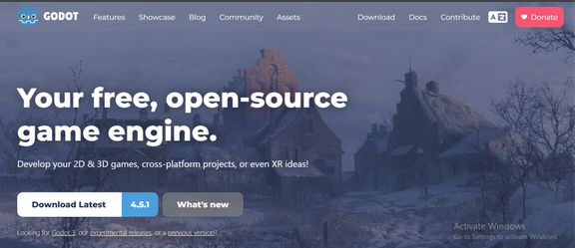

* Press on the download button “Download Latest” and once pressed you’ll see the following

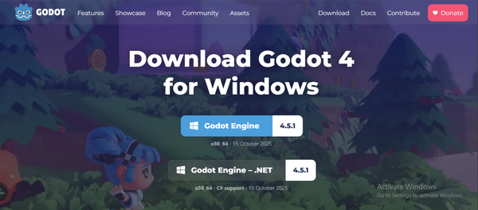

* Download “Godot Engine 4.5.1” and not “Godot Engine - .NET 4.5.1”. Once it is downloaded, locate the zip file in the download folder: C:\Users\Downloads\Godot_4.5.1-stable_win64.exe.zip

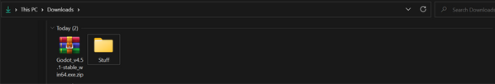

* Extract the folder (process pictured below), and by default, Godot engine is installed under C:\Users\PC\Downloads\Godot_v4.5.1-stable_win64.exe

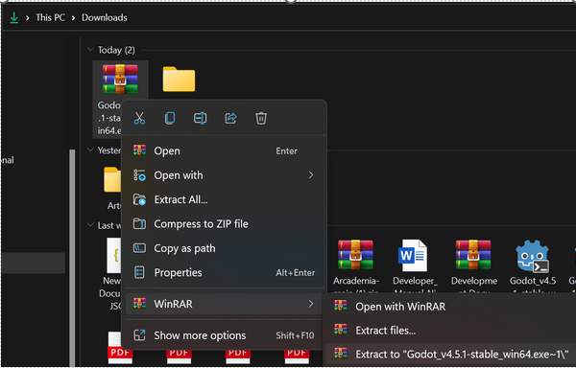

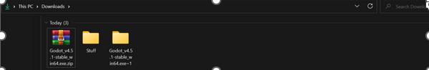

* Useful/necessary extensions to add to editor (Within Godot itself):
* **Keyboard:** A built-in keyboard created specifically for the purpose of supporting use of the Game program via an arcade box
* **Gitignore:** An extension for Godot that assists you in working with gitignore files. A very useful extension for source control. One can add a local .gitignore file by pulling .gitignore templates from the github/gitignore repository. It also provides language support for .gitignore files

## 3.2 GODOT WORKSPACE INTRODUCTION

This section provides an overview of the Godot Editor interface, outlining its main components and their purposes. It introduces the different panels, docks, and toolbars that make up the workspace, helping developers understand how the editor is organized and how each part contributes to creating and managing a game project.

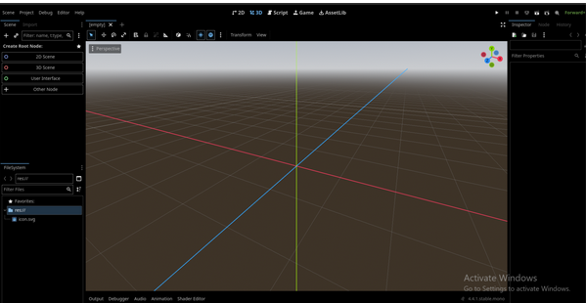

### 3.2.1 Main Menu Bar:

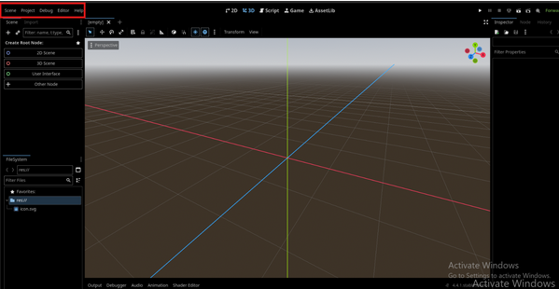

### 

### 3.2.2 Menus

* Scene – create new scenes, save/open scenes, reload scripts.
* Project – project settings, export templates, project configuration, autoload setup.
* Debug – control debugging features such as running scenes, viewing performance monitors, and enabling breakpoints.
* Editor – customize editor settings (themes, layout, input map, etc.).
* Help – access official documentation, class references, and about information.

### 3.2.3 Main Workspace Tabs

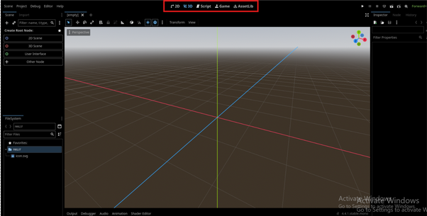

**Tabs:**

* 2D – switch to the 2D editor workspace (for 2D games/UI).
* 3D – switch to the 3D workspace .
* Script – open the script editor to write and edit GDScript.
* AssetLib – open Godot’s built-in Asset Library for downloading tools, scripts, and plugins.

### 3.2.4 Scene/Game Play Buttons

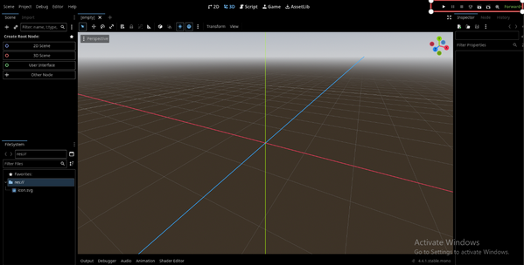

**Status Bar:**

* Forward+ – the active rendering backend (Forward+ or Compatibility).
* Play Icons – run the scene or project.
* Pause/Stop – debugging and runtime controls.

### 3.2.5 Scene Dock

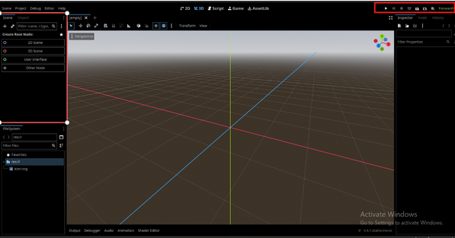

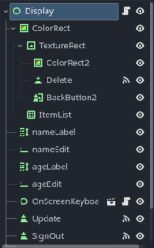

**StudentManager screen (Godot):**

* A single UI scene in which teachers can select a student, edit their name and age, and save or delete the record.
* ItemList displays students; selecting one fills the nameEdit and ageEdit fields.
* Update saves changes, while Delete removes the selected student.
* Back returns to the previous menu; SignOut terminates the session.
* The OnScreenKeyboard appears, allowing you to enter text using the joystick or buttons.
* ColorRect/TextureRect are simply background/visual elements.
* Signals link button and list selections to the script that loads, validates, saves, and refreshes data.

**Features:**

* Create Root Node – buttons to create:
* 2D Scene (Node2D-based)
* 3D Scene (Node3D-based)
* User Interface (Control-based)
* Other Node (manual node selection)
* Scene Tree – displays all nodes in the current scene (empty in your screenshot).
* Search Bar – filter node names/types.

### 3.2.6 FileSystem Dock

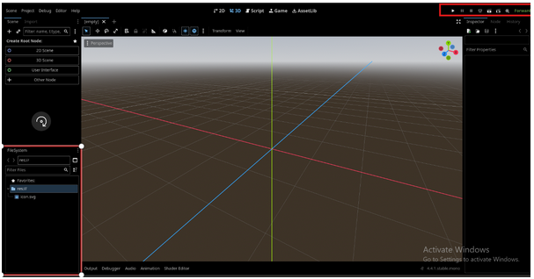 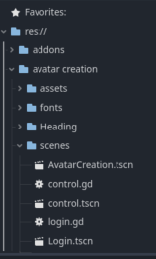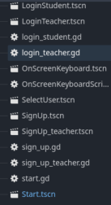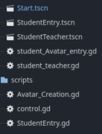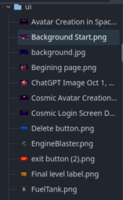

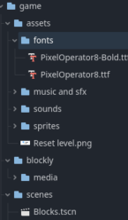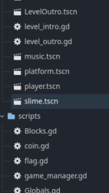

**Features:**

* Path Bar (res://) – indicates the project root directory.
* Filter Files – allows searching for assets by name or type.
* Favorites Section – quick access to frequently used folders.
* File List – displays files in the selected directory

### 3.2.7 In this Game

* **avatar creation/** – Login/Signup and Avatar screens (*.tscn) with their controller scripts (login_*.gd, sign_up*.gd, Avatar_Creation.gd). Handles user flow (student/teacher), on-screen keyboard, and profile setup.
* **game/** – The actual game.
  + **assets/**: fonts, music/sfx, sprites.
  + **blockly/media/**: art/media used by the block-based UI.
  + **scenes/**: level pieces (Blocks.tscn, platform.tscn, player.tscn, slime.tscn, intros/outros).
  + **scripts/**: gameplay logic (game_manager.gd, Blocks.gd, coin.gd, etc.).
* **ui/** – Backgrounds and UI images used by menus and screens.
* **Top scenes** – Start.tscn, StudentEntry.tscn, StudentTeacher.tscn are entry points that route between login, avatar creation, and the game

### 3.2.8 2D/3D Viewport

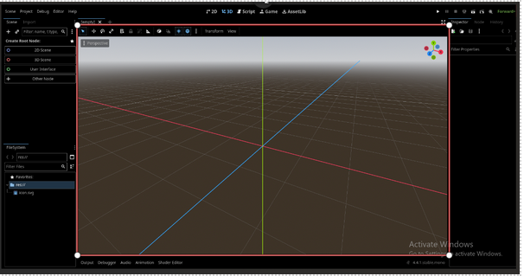 **Features:**

* Grid Floor – helps visualize spatial orientation in 3D space.
* Axes Lines:

-Red (X-axis)

-Green (Y-axis)

-Blue (Z-axis)

* Perspective Label – indicates the current camera mode
* Transform Gizmo – appears when you select a 3D object, enabling move/rotate/scale operations.
* Navigation Controls – mouse controls to orbit, pan, and zoom.

### 3.2.9 Inspector Dock

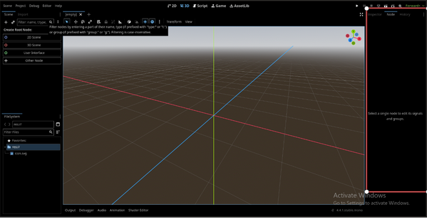

**Features:**

* Filter Properties – quickly locate a property by name.
* Expandable Categories – show editable attributes such as Transform, Material, Physics, etc.
* Dynamic Display – updates when different nodes or resources are selected.

### 3.2.10 Node Dock

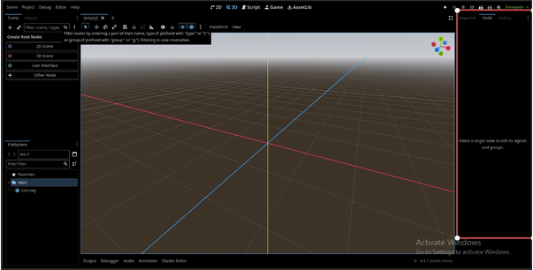

**Features:**

* Shows connected signals and available groups for the selected node.
* Allows connecting signals (e.g., button pressed) to script functions.

# 4. Database

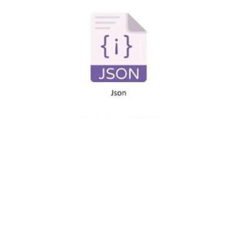JSON is a lightweight, text-based format used for storing and exchanging data. It is widely adopted in modern applications because of its simplicity, readability, and compatibility with various programming languages. Structured as key-value pairs, JSON makes it easy to organize and access information efficiently. It is particularly useful for web applications and NoSQL databases that require flexible, schema-less data storage. Being an open-standard and free-to-use format, JSON is supported by most modern technologies and platforms. It allows developers to represent complex data structures such as arrays and nested objects, and its data can be easily parsed and generated by languages like JavaScript, Python, Java, and C#, making it a versatile option for both frontend and backend systems. Unlike traditional relational databases, JSON stores data in a flexible document-based format rather than using fixed tables and schemas, making it ideal for projects that require fast data interchange, dynamic structures, and easy integration with APIs. JSON files are lightweight, efficient, and capable of handling large datasets without complex setup requirements. In this project the login name and password for students and teachers are saved to the JSON file and the scoring of the students, that is used to display the students name, password and scoring in the Student Management page and the score is shown after the game is played which will be discussed later.

# 5. Input Mapping and Key binds

## 5.1 HTML Level 1 – 4

The following code applies to Level 1 – 4.html with the exception of change_blocks for level 1.html:

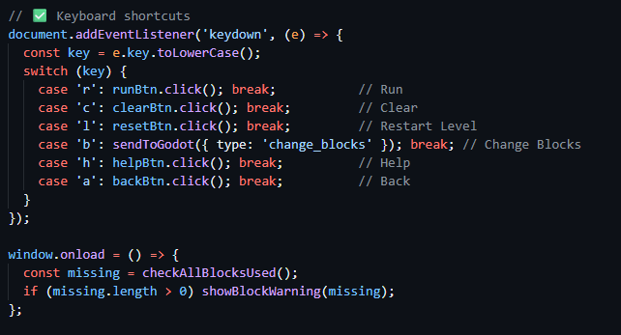

This code sets up keyboard shortcuts and an auto check when the page loads.

First it listens for any key pressed on the keyboard with document.addEventListener('keydown', ...). When a key is pressed, the event object (e) is used to see which key it was, and the code converts it to lowercase with e.key.toLowerCase() so both uppercase and lowercase letters work the same.

A switch statement then checks which key was pressed and does the corresponding action. **R** simulates the "Run" button, **C** simulates the "Clear" button to remove all blocks from the workspace. **L** simulates the "Reset Level" button, **B** sends the message { type: 'change_blocks' } to Godot (which probably changes the blocks or the programming mode). **H** opens the Help overlay by clicking the "Help" button and **A** activates the "Back" button to go back to the previous screen.

Finally, the window.onload function runs when the page is fully loaded; it checks if all required blocks are present with checkAllBlocksUsed() and if not, shows a warning message with showBlockWarning(missing). This way the user experience is improved with shortcuts and auto error feedback as soon as the interface loads.

The above keys are then mapped in JoyToKey to the corresponding buttons on the arcade machine explained further below.

## 5.2Mapping In JoyToKey

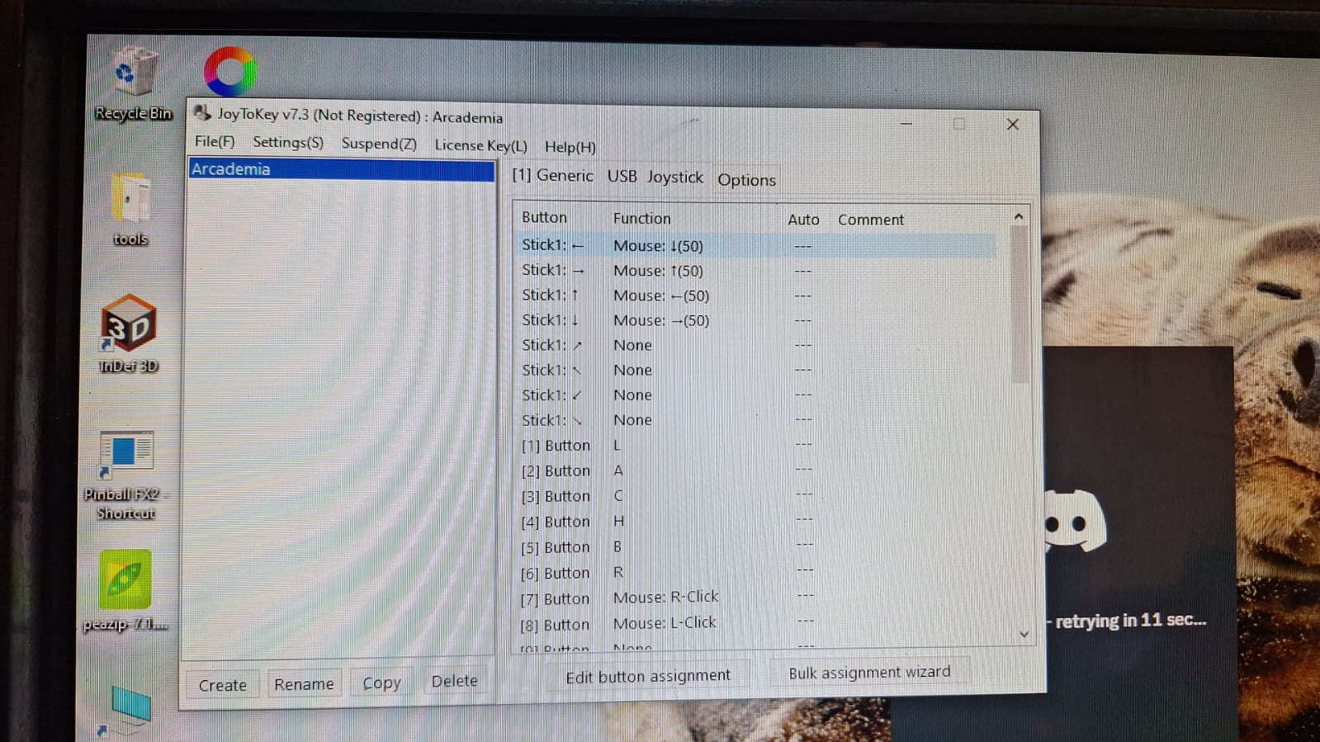

Figure:JoyToKey

## 5.3 The Joystick

In Godot, the joystick is effectively turned into a virtual mouse by having its analog stick movements translate into mouse motion events. This is done by mapping the joystick’s analog sticks values - JOY_AXIS_0 (Stick left and right) for left to right movement and JOY_AXIS_1 (Stick up and down) for up and down (Figure: JoyToKey) and turning them into pixel coordinates that move the on-screen mouse pointer. Doing this lets the joystick control the mouse cursor & interact with the game or UI elements just the same as a proper mouse device.

## 5.4 The Other Buttons on The Arcade Machine

The relevant keyboard input is mapped to the relevant buttons (Buttons [1] to Buttons [6]) and the Right Mouse Click and Left Mouse Click are then mapped to Buttons [7] and Buttons [8] accordingly as seen in Figure: JoyToKey

## 5.5 Mapping Of Buttons in Godot

### 5.5.1 Back Button

The following code applies to The Select User Page, Teacher and Student Login and SignUp pages, and the student management page on the teacher side.

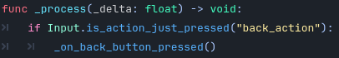

The _process(delta : float) function is a built-in Godot method that just keeps running while your game is running, it runs one time per frame. This script’s job is to keep an eye on what the player is doing; we check if the player has just pressed the "back_action" button using Input.is_action_just_pressed("back_action"). In our instance “back_action” is mapped to “A” in the Godot, Project Settings, Input Map settings. If that back action button does get pressed, this script immediately calls _on_back_button_pressed() function, please see below for more details on that function.

## 

The _on_back_button_pressed() function decides what happens when a player hits the back button. To start with it gives the player some feedback that the back button worked as expected by calling AudioManager.play_sound() , this plays the relevant music. Afterwards, the function changes the current scene over to the relevant page. The get_tree().change_scene_to_file("Relevant Page") bit does the actual scene switching, using Godot's scene tree system to make the transition between scenes nice and smooth.

## 5.6 Other Buttons

Other buttons are not required, as all primary actions are handled by the Left Click and Right Click buttons (Buttons [7] and [8]). Only a Back button is necessary, since further navigation can be done using the mouse and joystick.

# 6. Coding Explained

## 6.1 Start Screen

### 6.1.1 Class: Start Button Script



* **extends Node2D**: The script extends the Node2D class for managing 2D scene transitions.

### 6.1.2 Function: _on_start_button_1_pressed

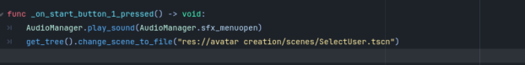

* **func _on_start_button_1_pressed() -> void:**: Handles the action when the start button is pressed.
  + **Plays sound effect**: Calls AudioManager.play_sound() to play the menu open sound, indicating the button press.
  + **Changes scene**: Loads the Select User scene using get_tree().change_scene_to_file().

## 6.2 Student Teacher Screen

### 6.2.1 Class: Scene Transition Script



**Explanation:**

* **extends Node2D**: The script extends the Node2D class for 2D scene management.

### 6.2.2 Function: _on_student_button_pressed

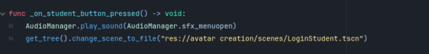

**Explanation:**

* **func _on_student_button_pressed() -> void:**: Handles the action when the student button is pressed.
  + **Plays sound effect**: Calls AudioManager.play_sound() to play the menu open sound.
  + **Changes scene**: Loads the Login Student scene using get_tree().change_scene_to_file().

### 6.2.3 Function: _on_teacher_button_pressed

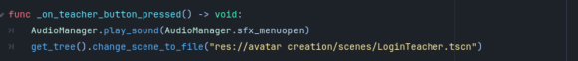

**Explanation:**

* **func _on_teacher_button_pressed() -> void:**: Handles the action when the teacher button is pressed.
  + **Plays sound effect**: Calls AudioManager.play_sound() to play the menu open sound.
  + **Changes scene**: Loads the Login Teacher scene using get_tree().change_scene_to_file().

### 6.2.4 Function: _process

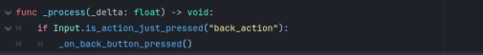

**Explanation:**

* **func _process(_delta: float) -> void:**: Called every frame to process input actions.
  + **Checks for back action**: Listens for the "back_action" input and calls the back button press function if detected.

### 6.2.5 Function: _on_back_button_pressed

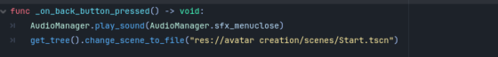

**Explanation:**

* **func _on_back_button_pressed() -> void:**: Handles the action when the back button is pressed.
  + **Plays sound effect**: Calls AudioManager.play_sound() to play the menu close sound.
  + **Changes scene**: Loads the Start scene using get_tree().change_scene_to_file().

## 6.3 Avatar Creation

### 6..3.1 Class Declaration



**Explanation:**

* This script inherits from Node2D, making it a 2D node that can e added to the scene tree and has 2D transformation properties (position, rotation, scale).



### 6.3.2 Variable Declarations-Texture Arrays

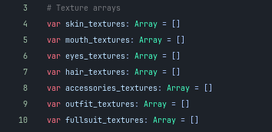

**Explanation:**

* These seven arrays store Texture objects. Each array holds all available texture options for one customization category. When populated, each element in the array is a texture resource load from disk.

### 6.3.3 Variable Declarations -Current Indices

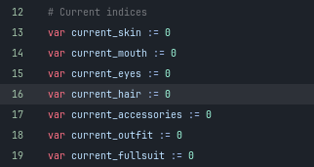

**Explanation:**

* These integers indicate which texture is currently selected in each category. They are indices that point to specific positions in the texture arrays. The: = operator infers the type as int and sets it to 0.

### 6.3.4 Variable Declarations-Backup Variables

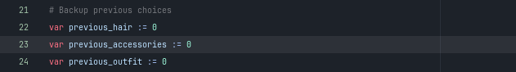

**Explanation:**

* These integers contain the index values of hair, accessories, and outfits before a full suit is applied. This enables the system to restore these options when the user removes the entire suit.

### 6.3.5 Node References- Avatar



**Explanation:**

* The @onready annotation indicates that this variable is assigned when _ready() is called. The $ operator retrieves a child node via path. This refers to the node at "CenterContainer/Skeleton", which contains all of the avatar's sprite layers.

### 6.3.6 Node References- Save Button



**Explaination:**

* It refers to the save button node. Connects the pressed button signal to a handler function.

### 6.3.7 Node References- Value Label Dictionary

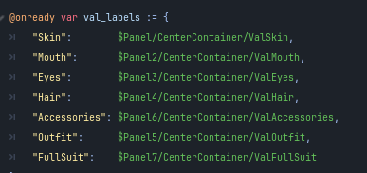

**Explanation:**

* This dictionary converts category names (strings) into Label nodes. Each label shows the name of the currently selected texture in its category. The keys are category identifiers, while the values are node references obtained via the $ path operator.

### 6.3.8 Node References- Previous Button Dictionary

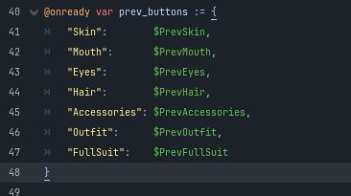

**Explanation:**

* The dictionary maps category names to "previous" button nodes. When pressed, these buttons cycle back through the texture options.

### 6.3.9 Node References-Next Button Dictionary

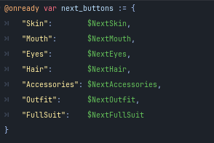

**Explanation:**

* The dictionary maps category names to the "next" button nodes. When clicked, these buttons cycle through the texture options.

### 6.3.10 Function: _ready()

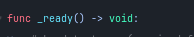

**Explanation:**

* This is a lifecycle method that is invoked automatically when the node enters the scene tree. The -> void indicates that it returns nothing.

### 6.3.11 Loading Required Textures

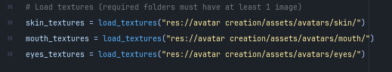

**Explanation:**

* These three lines invoke the load_textures() function for the specified categories. The function retrieves all PNG files from the specified directory paths and returns them in an array. The application will quit if there isn't at least one texture file in these categories.

### 6.3.12 Loading optional Textures

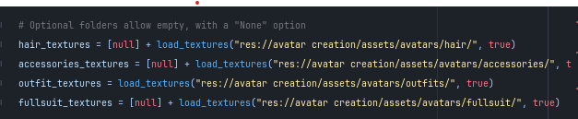

**Explanation:**

* [null] generates an array with one null element.   
  The + operator concatenates this with the loaded texture array.
* The second parameter, true, allows the directory to be empty without throwing an error.
* This adds a "None" option to index 0 for hair, accessories, and fullsuit.   
  Outfit does not receive the [null] prefix, but still allows empty directories.

### 6.3.13 Connecting Button Signal

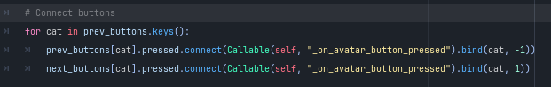

**Explanation:**

* for cat in previous_buttons.keys() iterates through all category names in the dictionary.
* "prev_buttons[cat]".pressed: Accesses the button's pressed signal.Connect() connects a signal to a callable function.
* Callable(self, "cycle_texture") creates a callable reference to the cycle_texture method. bind(cat, -1): Binds additional arguments to be passed when the signal fires (category name and direction).
* The following button uses 1 instead of -1 to cycle forward.

### 6.3.14 Connecting Save Button



**Explanation**:

* Connects the save button's pressed signal to the _on_save_button_pressed function. When the button is clicked, that function will execute.

### 6.3.15 Initial Updates

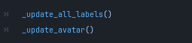

**Explanation:**

* Calls two functions to set up the display. First, all UI labels are updated with texture names, followed by the avatar visual, which shows the starting configuration.

### 6.3.16 Function: load_textures

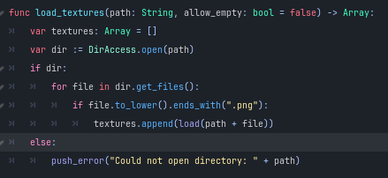

**Explanation:**

* Function load_textures(path: String, allow_empty: bool = false) -> Array:: Defines a function for loading PNG textures from a specified directory and returning them as an array.
* Variable textures: Array = []: Creates an empty array named textures for storing loaded images.
* var dir:= DirAccess.open(path): Attempts to open the directory identified by path.
* if dir: Determines whether the directory was successfully opened.
* For file in dir.get_files(): Iterates through all of the files in the opened directory.
* if file.to_lower().ends_with(".png"):: Checks whether the current file has a.png extension (case insensitive).
* textures.append(load(path + file)): Loads the valid PNG file into the textures array.  
  else: Executes if the directory could not be opened.

### 6.3.17 Function: _name()

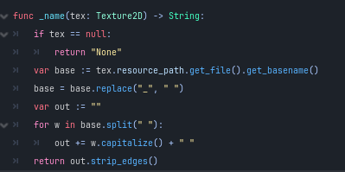

**Explanation:**

* **func _name(tex: Texture2D) -> String:**: Defines a function that retrieves a formatted name from a given texture.
* **if tex == null:**: Checks if the texture is null (not assigned).
* **return "None"**: Returns the string "None" if the texture is not valid.
* **var base := tex.resource_path.get_file().get_basename()**: Gets the base filename of the texture's resource path.
* **base = base.replace("_", " ")**: Replaces underscores in the base name with spaces for better readability.
* **var out := ""**: Initializes an empty string out to accumulate the formatted words.
* **for w in base.split(" "):**: Iterates through each word in the base name, split by spaces.
* **out += w.capitalize() + " "**: Capitalizes each word and adds it to the output string with a trailing space.
* **return out.strip_edges()**: Returns the final formatted string, removing any leading or trailing spaces.

### 6.3.17 Function: _update_all_labels

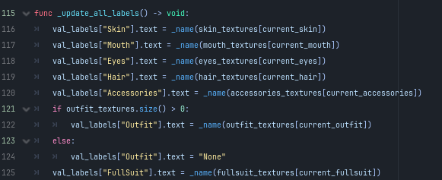

**Explanation:**

* The _update_all_labels function updates the text labels for various texture categories.
* It assigns formatted names to the "Skin," "Mouth," "Eyes," "Hair," and "Accessories" labels based on their respective textures.
* It checks for outfit textures; if available, it updates the "Outfit" label, otherwise sets it to "None."
* Lastly, it updates the "FullSuit" label with the current full suit texture name.

### 6.3.18 Function: Update-Avatar

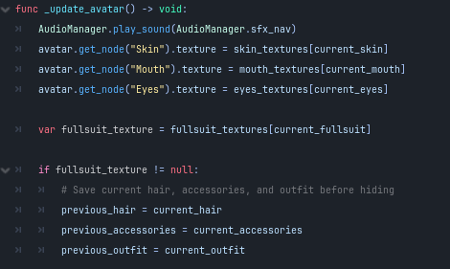

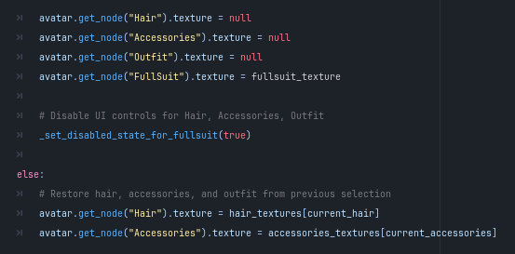

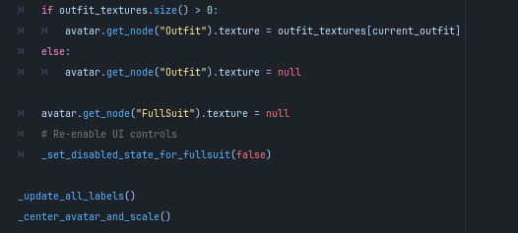

**Explanation:**

* The _update_avatar function updates the avatar's appearance and plays a navigation sound.
* It sets the textures for "Skin," "Mouth," and "Eyes" based on the current selections.
* It checks if a full suit texture is available. If so, it saves the current hair, accessories, and outfit, then hides them and applies the full suit texture.
* UI controls for hair, accessories, and outfit are disabled when the full suit is active.
* If no full suit is available, it restores the hair, accessories, and outfit textures from previous selections and sets the full suit texture to null.
* UI controls are re-enabled, and the function calls _update_all_labels() and _center_avatar_and_scale() to finalize the updates.

### 6.3 19 Function: cycle-texture

****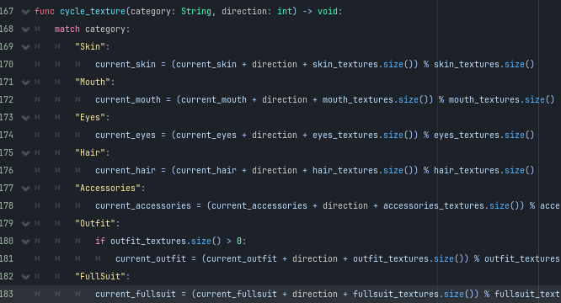

**Explanation:**

* The cycle_texture function changes the current texture category based on the provided direction.
* It uses a match statement to handle different categories: "Skin," "Mouth," "Eyes," "Hair," "Accessories," "Outfit," and "FullSuit."
* For each category, it updates the corresponding current index by adding the direction, normalizing it with the texture array size to loop through options.
* For the "Outfit" category, it only updates if there are available outfit textures.
* After updating the current texture index, the function calls _update_avatar() to apply the changes.

### 6.3.20 Function: _center_avatar_and_scale

**Explanation:**

* The _center_avatar_and_scale function centers and scales the avatar to fit a target display size.
* It defines a display_size of Vector2(598, 650) as the desired size for the avatar display.
* It retrieves the "Skin" node from the avatar and checks if it exists and has a texture.
* If the texture is valid, it gets its size using get_size().
* It calculates a scale_factor based on the display size and texture size, ensuring the avatar fits within the display.
* The scale is then increased by 20% (multiplied by 1.2) and applied to the avatar's scale.
* Finally, it centers the avatar's position by setting it to half of the display size.

### 6.3.21 Function: _set_disabled_state_for_fullsuit

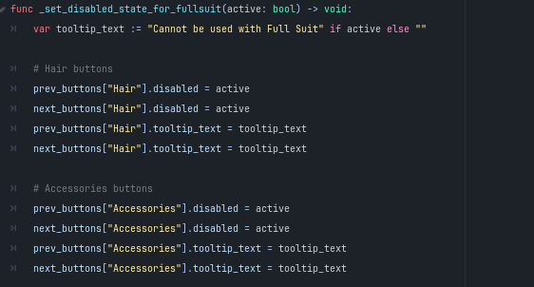

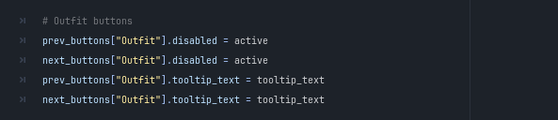

**Explanation:**

* The _set_disabled_state_for_fullsuit function toggles the disabled state of UI controls related to hair, accessories, and outfits when a full suit is active.
* It sets a tooltip_text to indicate that these options cannot be used with a full suit, depending on the active boolean.
* For the hair buttons, it disables both the previous and next buttons and assigns the tooltip text.
* The same process is repeated for the accessories buttons, disabling them and adding the tooltip.
* Finally, it applies the same changes to the outfit buttons, ensuring they are disabled and have the tooltip text set.

### 6.3.22 Function: _process

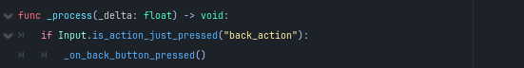

**Explanation:**

* The _process function is called every frame and checks for user input.
* It listens for the "back_action" input.
* If the action is just pressed, it calls the _on_back_button_pressed() function to handle the back button event.

### 6.3.23 Function: _on_back_button_pressed

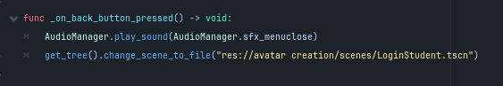

**Explanation:**

* The _on_back_button_pressed function handles the back button press event.
* It plays a sound effect for closing the menu using AudioManager.play_sound(AudioManager.sfx_menuclose).
* The function then changes the current scene to the "LoginStudent" scene by calling get_tree().change_scene_to_file("res://avatar creation/scenes/LoginStudent.tscn").

### 6.3.24 Function: _on_save_pressed

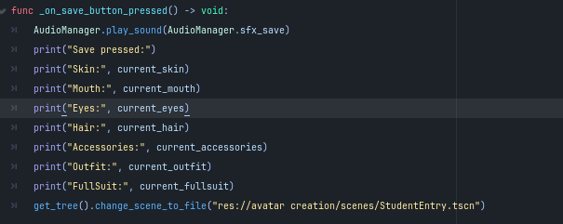

**Explanation:**

* The _on_save_button_pressed function is triggered when the save button is pressed.
* It plays a save sound effect using AudioManager.play_sound(AudioManager.sfx_save).
* The function prints the current selections for skin, mouth, eyes, hair, accessories, outfit, and full suit to the console.
* Finally, it changes the scene to "StudentEntry" by calling get_tree().change_scene_to_file("res://avatar creation/scenes/StudentEntry.tscn").

## 

## 6.4 Student Login

### 6.4.1 Class Declaration



**Explanation:**

* This script inherits from Node2D, making it a 2D node that can be added to the scene tree and has 2D transformation properties (position, rotation, scale).

### 6.4.2 Variable Declarations and Initializations

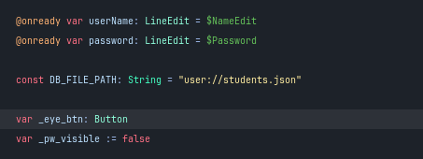

**Explanation:**

* **var userName: LineEdit = $NameEdit**: Declares a variable userName of type LineEdit, referencing the UI element for name input.
* **var password: LineEdit = $Password**: Declares a variable password of type LineEdit, referencing the UI element for password input.
* **const DB_FILE_PATH: String = "user://students.json"**: Defines a constant DB_FILE_PATH as a string that specifies the path to the JSON file for student data.
* **var _eye_btn: Button**: Declares a variable _eye_btn of type Button for managing the visibility of the password.
* **var _pw_visible := false**: Initializes a boolean variable _pw_visible to false, indicating that the password is not currently visible.

### 6.4.3 Function: _ready()-Password should not show

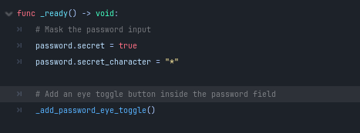

**Explanation:**

* The _ready function is called when the node is added to the scene.
* It configures the password input by setting password.secret to true, which masks the input.
* The password.secret_character is set to "*" to display asterisks for each character entered.
* Finally, it calls the _add_password_eye_toggle() function to add an eye toggle button inside the password field for visibility control.

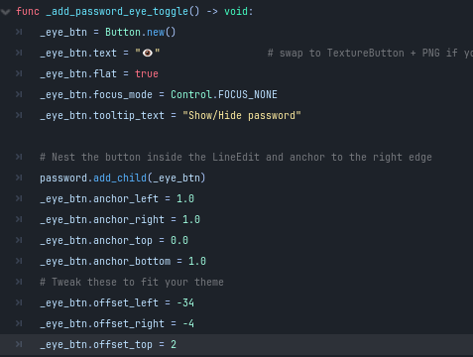

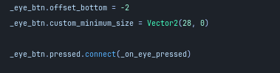

**Explanation:**

This function creates and configures a button inside the password field that allows users to toggle password visibility.

* A new Button instance is created with an eye emoji as its display text.
* The flat property is set to true, removing the button's background styling to make it blend seamlessly into the password field.
* The focus_mode is set to Control.FOCUS_NONE, preventing the button from capturing keyboard focus and keeping it on the text input.
* A tooltip provides helpful text when the user hovers over the button.
* The button is added as a child of the password LineEdit using add_child(), nesting it inside the field.
* The anchor properties position the button: anchor_left and anchor_right are set to 1.0, anchoring it to the right edge of its parent container.
* anchor_top and anchor_bottom are set to 0.0 and 1.0, making it stretch vertically to fill the field's height.
* Offset properties are adjusted with negative values to move the button inward from the right edge, fine-tuning its position.
* The custom_minimum_size ensures the button maintains a width of 28 pixels.
* Finally, the button's pressed signal is connected to the _on_eye_pressed() function, allowing it to toggle the password visibility when clicked.

### 6.4.4 Function: _on_eye_pressed()

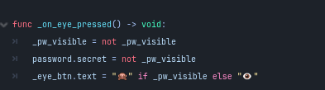

**Explanation:**

* This function runs whenever the eye button is clicked and handles toggling between showing and hiding the password.
* If _pw_visible boolean was false, it becomes true, and vice versa. This boolean tracks the current visibility state.
* The second line updates the password field's secret property to match the opposite of _pw_visible: when _pw_visible is true (password should be shown), secret becomes false (no masking), and when _pw_visible is false (password should be hidden), secret becomes true (text is masked).
* The final line uses a ternary operator to change the eye button's emoji: if the password is visible, the button shows a closed eye emoji "🙈" to indicate that clicking it will hide the password; if the password is hidden, it shows an open eye emoji "👁" to indicate that clicking it will show the password.

### 6.4.5 Function: save_button_pressed

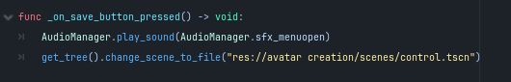

**Explanation:**

* This function is called when the "Save" button is pressed. It serves as a simple scene transition without requiring login verification.
* The function first plays a menu open sound effect through AudioManager, providing audio feedback to the user. Then it uses get_tree().change_scene_to_file() to navigate to a different scene, loading the avatar creation scene from the specified path. This creates a smooth user experience by accompanying the scene change with sound. This function might be used for a "Skip" or "Next" button that allows users to navigate without logging in, or it could be connected to a button that leads elsewhere in the application flow

### 6.4.6 Function: _on_save_button_2_pressed

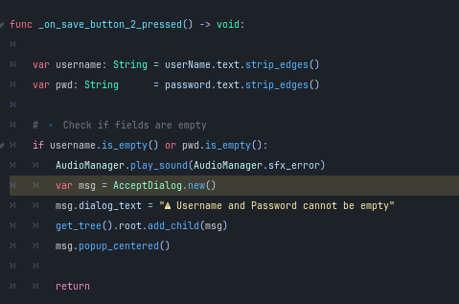

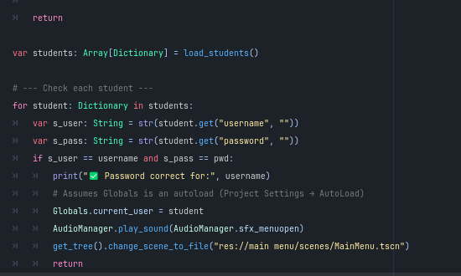

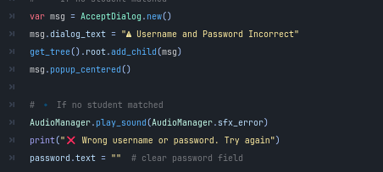

**Explanation:**

* **var username: String = userName.text.strip_edges()**: Retrieves the username from the input field, stripping extra spaces.
* **var pwd: String = password.text.strip_edges()**: Retrieves the password from the input field, stripping extra spaces.
* **Check for Empty Fields**: If either field is empty, play an error sound and display a dialog warning that both fields must be filled.
* **Load Student Data**: Loads the list of registered students.
* **Verify Credentials**: Iterates through the students, checking for matching username and password. If matched, updates the current user and changes the scene to the main menu.
* **Handle No Matches**: If no match is found, display an error dialog, play an error sound, and clear the password field.

### 6.4.7 Function: Load_Students

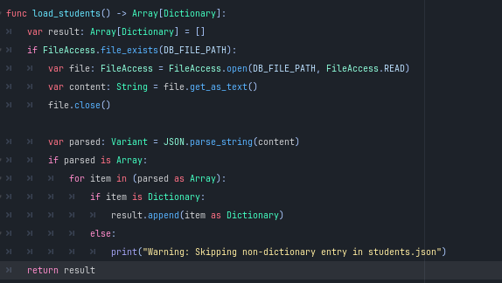

**Explanation:**

* **var result: Array[Dictionary] = []**: Initializes an empty array to store student data.
* **if FileAccess.file_exists(DB_FILE_PATH):**: Checks if the file specified by DB_FILE_PATH exists.
* **var file: FileAccess = FileAccess.open(DB_FILE_PATH, FileAccess.READ)**: Opens the file for reading.
* **var content: String = file.get_as_text()**: Reads the entire file content as text.
* **file.close()**: Closes the file after reading.
* **var parsed: Variant = JSON.parse_string(content)**: Parses the JSON content into a variant.
* **if parsed is Array:**: Checks if the parsed data is an array.
* **for item in (parsed as Array):**: Iterates through each item.
  + **if item is Dictionary:**: If the item is a dictionary, appends it to the result array.
  + **print("Warning: Skipping non-dictionary entry in students.json")**: Prints a warning for any non-dictionary entries.
* **return result**: Returns the array of student dictionaries.

### 6.4.8 Function: _process

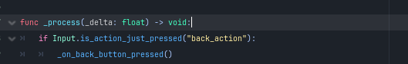

**Explanation:**

* **func _process(_delta: float) -> void:**: Called every frame to update the state of the node.
* **if Input.is_action_just_pressed("back_action"):**: Checks if the back action is pressed.
  + **_on_back_button_pressed()**: Calls the function to handle the back button press.

### 6.4.9 Function: _on_back_button_pressed

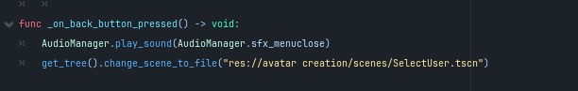

**Explanation:**

* **func _on_back_button_pressed() -> void:**: Handles the action when the back button is pressed.
* **AudioManager.play_sound(AudioManager.sfx_menuclose)**: Plays the sound effect for closing the menu.
* **get_tree().change_scene_to_file("res://avatar creation/scenes/SelectUser.tscn")**: Changes the current scene to the Select User scene.

## 6.5 Login for Teachers

### 6.5.1 Class: Main Scene Script

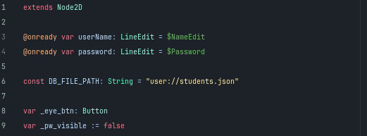

**Explanation:**

* **extends Node2D**: The script extends the Node2D class, allowing for 2D node functionality.
* **@onready var userName: LineEdit = $NameEdit**: References the UI element for the username input.
* **@onready var password: LineEdit = $Password**: References the UI element for the password input.
* **const DB_FILE_PATH: String = "user://students.json"**: Specifies the path to the JSON file for student data.
* **var _eye_btn: Button**: Declares a button for toggling password visibility.
* **var _pw_visible := false**: Initializes a boolean to track password visibility.

### 6.5.2Function: _ready

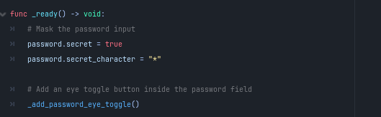

**Explanation:**

* **func _ready() -> void:**: Called when the node is added to the scene.
  + **password.secret = true**: Masks the password input.
  + **password.secret_character = "*"**: Sets the character for masked input.
  + **_add_password_eye_toggle()**: Calls the function to add the eye toggle button.

### 6.5.3 Function: _add_password_eye_toggle

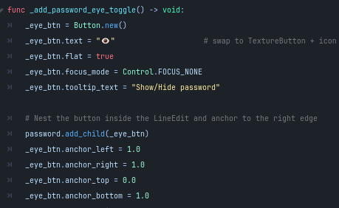

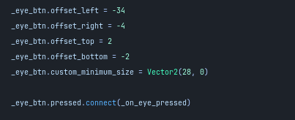

**Explanation:**

* **func _add_password_eye_toggle() -> void:**: Creates a button to show/hide the password.
  + **_eye_btn = Button.new()**: Initializes a new button.
  + **_eye_btn. Text = "👁"**: Sets the button text to an eye emoji.
  + **_eye_btn.flat = true**: Removes background styling for a seamless look.
  + **_eye_btn.focus_mode = Control.FOCUS_NONE**: Prevents the button from capturing focus.
  + **_eye_btn.tooltip_text = "Show/Hide password"**: Adds a tooltip for user guidance.
  + **password.add_child(_eye_btn)**: Adds the button inside the password field.
  + **Anchoring and positioning**: Sets the button's anchors and offsets to fit the UI.

### 6.5.4 Function: _on_eye_pressed

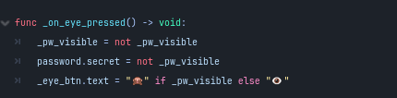

**Explanation:**

* **func _on_eye_pressed() -> void:**: Toggles password visibility.
  + **_pw_visible = not _pw_visible**: Flips the visibility state.
  + **password.secret = not _pw_visible**: Updates the password field visibility.
  + **_eye_btn.text = "🙈" if _pw_visible else "👁"**: Changes the button icon based on visibility.

### 6.5.5 Function: _on_save_button_pressed

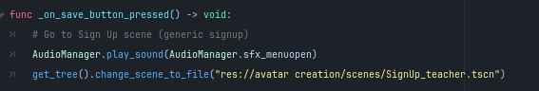

**Explanation:**

* **func _on_save_button_pressed() -> void:**: Handles save action to navigate to the Sign-Up scene.
  + **AudioManager.play_sound(AudioManager.sfx_menuopen)**: Plays a sound effect.
  + **get_tree().change_scene_to_file("res://avatar creation/scenes/SignUp_teacher.tscn")**: Changes the scene to the sign-up screen.

### 6.5.6 Function: _on_save_button_2_pressed

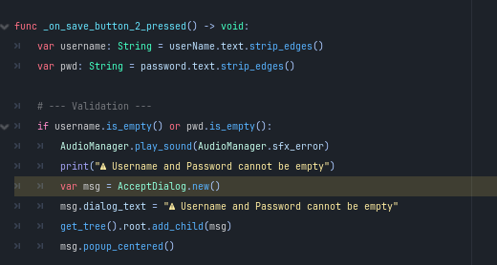

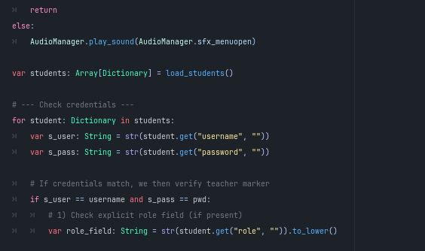

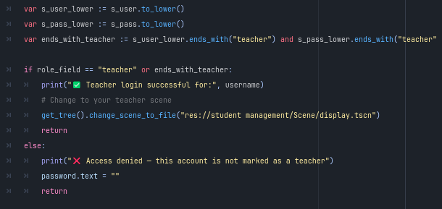

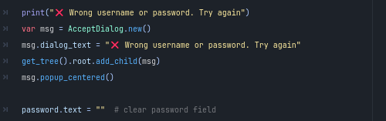

**Explanation:**

* **func _on_save_button_2_pressed() -> void:**: Handles user login action.
  + **Retrieves input**: Strips spaces from username and password.
  + **Validation check**: If fields are empty, plays an error sound and shows a warning dialog.
  + **Loads student data**: Calls load_students() to get registered users.
  + **Credential verification**: Iterates through students to check for matching credentials and role verification.
  + **Successful login**: If credentials match and the user is a teacher, navigates to the teacher scene.
  + **Access denied**: If not a teacher, clears the password field and prints a message.
  + **No match handling**: If no match is found, displays an error dialog and clears the password field.

### 6.5.7 Function: load_students

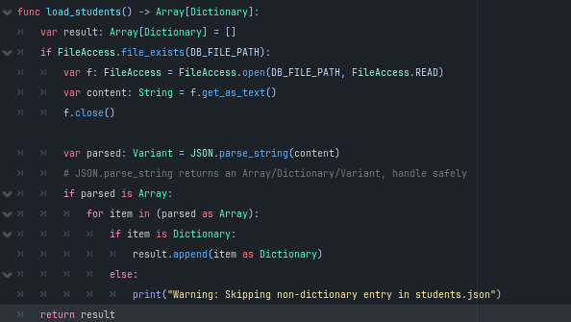

**Explanation:**

* **func load_students() -> Array[Dictionary]:**: Loads student data from a JSON file.
  + **Initializes result array**: Creates an empty array for storing student dictionaries.
  + **File check**: If the file exists, opens it for reading.
  + **Reads content**: Gets the file content as text and closes the file.
  + **Parses JSON**: Converts the text content into a variant.
  + **Handles parsed data**: Checks if parsed data is an array and appends valid dictionaries to the result.

### 6.5.8 Function: _process

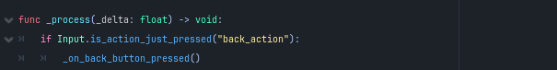

**Explanation:**

* **func _process(_delta: float) -> void:**: Called every frame to update the state.
  + **Input check**: If the back action is pressed, calls _on_back_button_pressed().

### 6.5.9 Function: _on_back_button_pressed

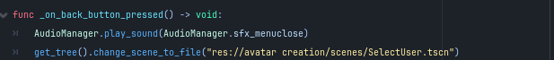

**Explanation:**

* **func _on_back_button_pressed() -> void:**: Handles the back button action.
  + **AudioManager.play_sound(AudioManager.sfx_menuclose)**: Plays a sound effect for closing the menu.
  + **get_tree().change_scene_to_file("res://avatar creation/scenes/SelectUser.tscn")**: Changes the scene to the Select User screen.

## 6.6 Signup Teachers

### 6.6.1 Class: Main Scene Script



**Explanation:**

* **extends Node2D**: The script extends the Node2D class for 2D functionality.

### 6.6.2 Nodes

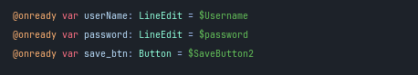

**Explanation:**

* **@onready var userName: LineEdit = $Username**: References the UI element for username input.
* **@onready var password: LineEdit = $password**: References the UI element for password input.
* **@onready var save_btn: Button = $SaveButton2**: References the save button for creating a teacher account.

### 6.6.3 Constants



**Explanation:**

* **const DB_FILE_PATH: String = "user://students.json"**: Specifies the path to the JSON file for student data.

### 6.6.4 Variables



**Explanation:**

* **var _eye_btn: Button**: Declares a button for toggling password visibility.
* **var _pw_visible: bool = false**: Initializes a boolean to track password visibility.

### 6.6.5 Function: _ready

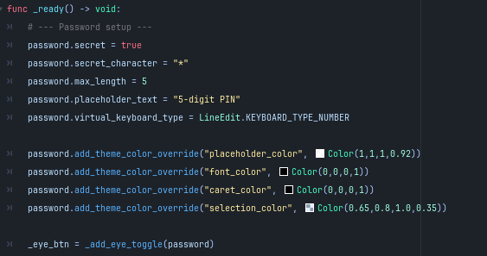

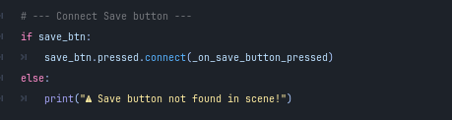

**Explanation:**

* **func _ready() -> void:**: Called when the node is added to the scene.
  + **Password setup**:
    - Masks the password input.
    - Sets the maximum length to 5 digits.
    - Configures the virtual keyboard for numeric input.
    - Applies theme color overrides for the password field.
  + **_eye_btn = _add_eye_toggle(password)**: Calls the function to add the eye toggle button.
  + **Connects the save button**: Attaches the pressed signal to _on_save_button_pressed.

### 6.6.6 Function: _add_eye_toggle

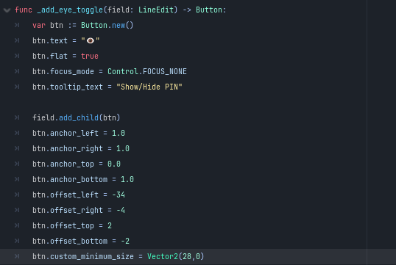

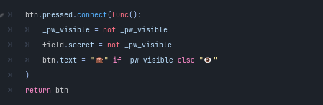

**Explanation:**

* **func _add_eye_toggle(field: LineEdit) -> Button:**: Creates a button to show/hide the password.
  + **Button initialization**: Creates and configures the button.
  + **Button positioning**: Anchors and positions the button within the password field.
  + **Toggle functionality**: Connects the button press to toggle password visibility and updates the button text.

### 6.6.7 Function: _on_save_button_pressed

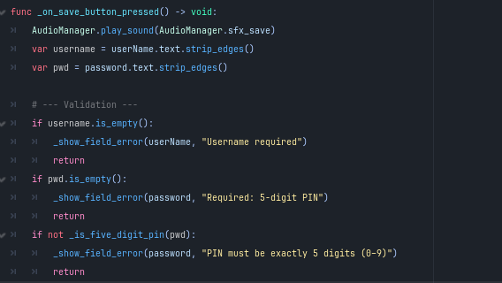

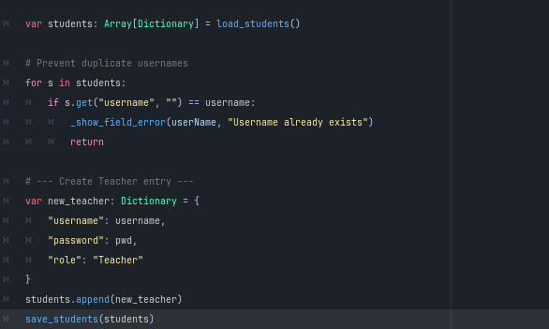

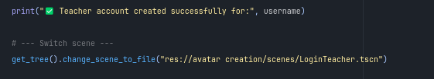

**Explanation:**

* **func _on_save_button_pressed() -> void:**: Handles the save action to create a teacher account.
  + **Plays save sound**: Triggers a sound effect.
  + **Retrieves user input**: Strips spaces from username and password.
  + **Validation checks**:
    - Ensures username is not empty.
    - Ensures password is not empty and is a valid 5-digit PIN.
  + **Load student data**: Calls load_students() to get existing users.
  + **Duplicate check**: Prevents duplicate usernames by checking against existing usernames.
  + **Creates a new teacher entry**: Adds the new teacher's information to the student data.
  + **Saves updated student data**: Calls save_students() to write the new data.
  + **Scene change**: Navigates to the login scene after successful account creation.

### 6.6.8 Inline Error Helpers

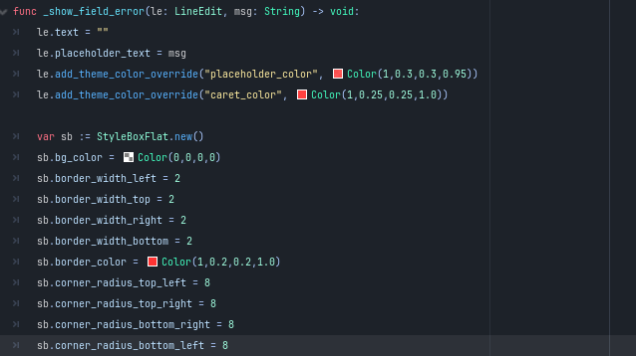

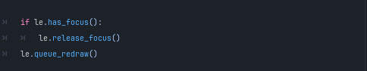

**Explanation:**

* **func _show_field_error(le: LineEdit, msg: String) -> void:**: Displays an error message in the specified LineEdit.
  + **Clears text and sets placeholder**: Updates the placeholder to show the error message.
  + **Applies visual error styling**: Changes colors and styles to indicate an error.
  + **Releases focus**: If the field has focus, it releases it and queues a redraw.
* **func _clear_field_error(le: LineEdit) -> void:**: Resets the error state for the specified LineEdit.

### 6.6.9 Function: _is_five_digit_pin

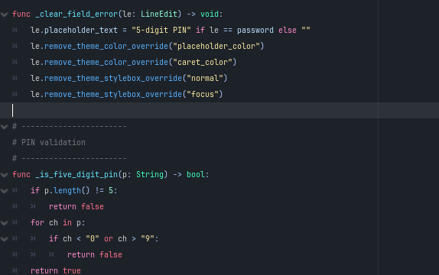

**Explanation:**

* **func _is_five_digit_pin(p: String) -> bool:**: Validates that the PIN is exactly 5 digits.
  + **Length check**: Confirms the length is 5.
  + **Character check**: Ensures all characters are numeric.

### 6.6.10 Data Helpers

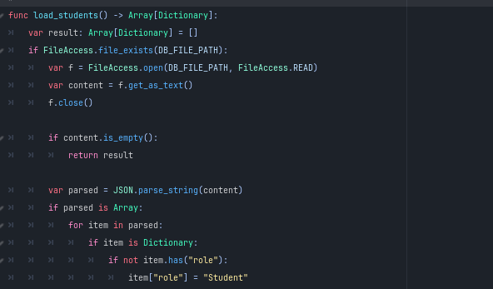

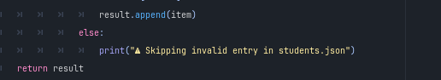

**Explanation:**

* **func load_students() -> Array[Dictionary]:**: Loads student data from a JSON file.
  + **Initializes result array**: Creates an empty array for storing student dictionaries.
  + **File check**: If the file exists, opens it for reading and retrieves the content.
  + **Parses JSON**: Converts the text content into a variant and checks for valid entries.
  + **Sets default role**: Assigns a default role of "Student" if not present.
* **func save_students(students: Array[Dictionary]) -> void:**: Saves the student data to the JSON file.
  + **Opens file for writing**: Writes the data as a formatted JSON string.

### 6.6.11 Function: _process

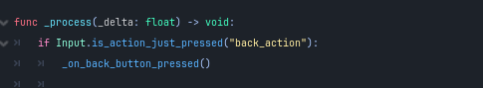

**Explaining:**

* **func _process(_delta: float) -> void:**: Called every frame to update the state.
  + **Input check**: If the back action is pressed, calls _on_back_button_pressed().

### 6.6.12 Function: _on_back_button_pressed

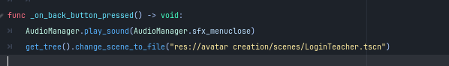

**Explanation:**

* **func _on_back_button_pressed() -> void:**: Handles the back button action.
  + **Plays menu close sound**: Triggers a sound effect.
  + **Scene change**: Navigates back to the login scene.

## 6.7 Student Signup

### 6.7.1 Class: Main Scene Script



**Explanation:**

* **extends Node2D**: The script extends the Node2D class for 2D functionality.

### 6.7.2 Nodes



**Explanation:**

* **@onready var userName: LineEdit = $NameEdit**: References the UI element for username input.
* **@onready var password: LineEdit = $PasswordEdit**: References the UI element for password input.

### 6.7.3 Constants



**Explanation:**

* **const DB_FILE_PATH: String = "user://students.json"**: Specifies the path to the JSON file for student data.

### 6.7.4 Variables



**Explanation:**

* **var _eye_btn: Button**: Declares a button for toggling password visibility.
* **var _pw_visible := false**: Initializes a boolean to track password visibility.

### 6.7.5 Function: _ready

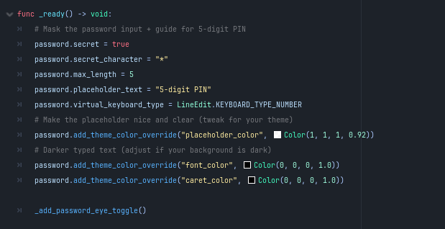

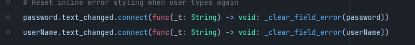

**Explanation:**

* **func _ready() -> void:**: Called when the node is added to the scene.
  + **Password setup**:
    - Masks the password input and sets its properties for a 5-digit PIN.
    - Applies theme color overrides for the password field.
  + **Adds password eye toggle**: Calls _add_password_eye_toggle().
  + **Resets error styling**: Connects the text_changed signal of the input fields to _clear_field_error().

### 6.7.6 Function: _add_password_eye_toggle

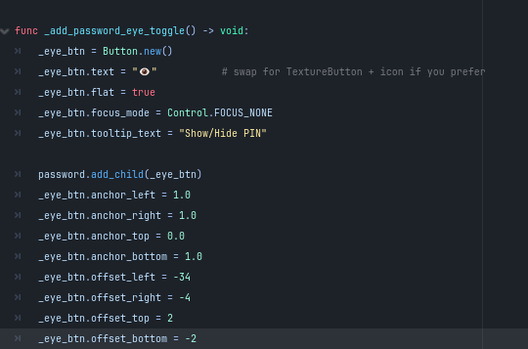

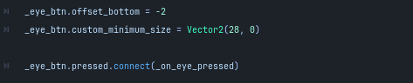

**Explanation:**

* **func _add_password_eye_toggle() -> void:**: Creates a button to show/hide the password.
  + **Button initialization**: Creates and configures the button.
  + **Button positioning**: Anchors and positions the button within the password field.
  + **Connects toggle functionality**: Connects the button press to _on_eye_pressed.

### 6.7.7 Function: _on_eye_pressed

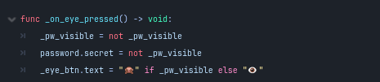

**Explanation:**

* **func _on_eye_pressed() -> void:**: Toggles password visibility.
  + **Updates visibility state**: Flips the _pw_visible boolean and updates the password field.
  + **Changes button text**: Updates the button to reflect the current visibility state.

### 6.7.8 Function: _on_save_button_pressed

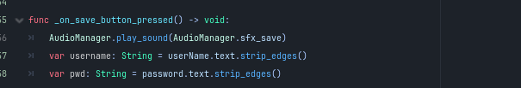

**Explanation:**

* **func _on_save_button_pressed() -> void:**: Handles the save action to create a new student account.
  + **Plays save sound**: Triggers a sound effect.
  + **Retrieves user input**: Strips spaces from username and password.
  + **Validation checks**:
    - Ensures username is not empty.
    - Ensures password is not empty and is a valid 5-digit PIN.
    - If any field is invalid, plays an error sound and returns.
  + **Create new student entry**: Constructs a dictionary for the new student.
  + **Load existing students**: Calls load_students() to retrieve existing users.
  + **Duplicate check**: Prevents duplicate usernames by checking against existing usernames.
  + **Adds new student**: Appends the new student to the array and saves it.
  + **Sets current user**: Calls Globals.set_current_user() to set the current user for the session.
  + **Scene change**: Navigates to the main menu scene after saving.

### 6.7.9 Inline Error Helpers

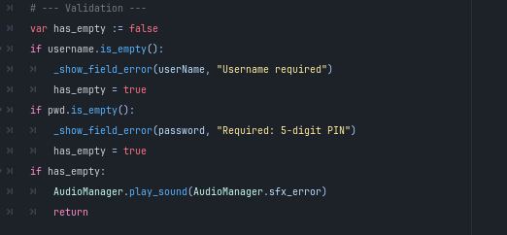

**Explanation:**

* **func _show_field_error(le: LineEdit, msg: String) -> void:**: Displays an error message in the specified LineEdit.
  + **Clears text and sets placeholder**: Updates the placeholder to show the error message.
  + **Applies visual error styling**: Changes colors and styles to indicate an error.
  + **Releases focus**: If the field has focus, it releases it and queues a redraw.
  + **Calls shake effect**: Triggers _shake_line_edit() to give visual feedback.
* **func _clear_field_error(le: LineEdit) -> void:**: Resets the error state for the specified LineEdit.
* **func _shake_line_edit(le: LineEdit) -> void:**: Creates a shaking effect on the specified LineEdit for error feedback.
  + **Animates position**: Uses a tween to shake the input field left and right.

### 6.7.10 Function: _is_five_digit_pin

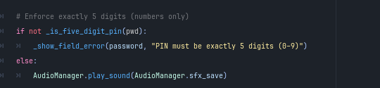

**Explanation:**

* **func _is_five_digit_pin(p: String) -> bool:**: Validates that the PIN is exactly 5 digits.
  + **Length check**: Confirms the length is 5.
  + **Character check**: Ensures all characters are numeric.

### 6.7.11 Data Helpers

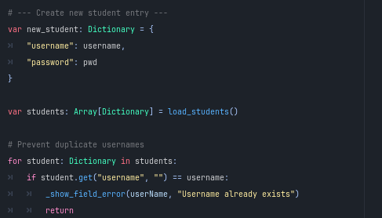

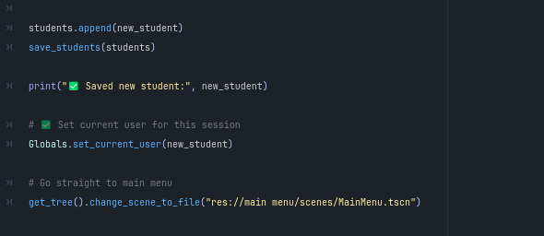

**Explanation:**

* **func load_students() -> Array[Dictionary]:**: Loads student data from a JSON file.
  + **Initializes result array**: Creates an empty array for storing student dictionaries.
  + **File check**: If the file exists, opens it for reading and retrieves the content.
  + **Parses JSON**: Converts the text content into a variant and checks for valid entries.
* **func save_students(students: Array[Dictionary]) -> void:**: Saves the student data to the JSON file.
  + **Opens file for writing**: Writes the data as a formatted JSON string.

### 6.7.12 Function: _process

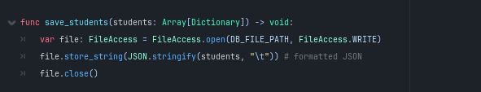

**Explanation:**

* **func _process(_delta: float) -> void:**: Called every frame to update the state.
  + **Input check**: If the back action is pressed, calls _on_back_button_pressed().

### 6.7.13 Function: _on_back_button_pressed

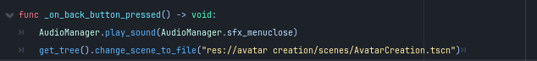

**Explanation:**

* **func _on_back_button_pressed() -> void:**: Handles the back button action.
  + **Plays menu close sound**: Triggers a sound effect.
  + **Scene change**: Navigates back to the Avatar Creation scene.

## 6.8 The Game

## Blocks.gd

### 6.8.1 Class: Blocks Script



**Explanation:**

* **extends Node2D**: The script extends the Node2D class for 2D functionality.

### 6.8.2 Nodes

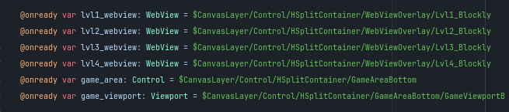

**Explanation:**

* **@onready var lvl1_webview: WebView = $CanvasLayer/Control/HSplitContainer/WebViewOverlay/Lvl1_Blockly**: References the web view for Level 1.
* **@onready var lvl2_webview: WebView = $CanvasLayer/Control/HSplitContainer/WebViewOverlay/Lvl2_Blockly**: References the web view for Level 2.
* **@onready var lvl3_webview: WebView = $CanvasLayer/Control/HSplitContainer/WebViewOverlay/Lvl3_Blockly**: References the web view for Level 3.
* **@onready var lvl4_webview: WebView = $CanvasLayer/Control/HSplitContainer/WebViewOverlay/Lvl4_Blockly**: References the web view for Level 4.
* **@onready var game_area: Control = $CanvasLayer/Control/HSplitContainer/GameAreaBottom**: References the control for the game area.
* **@onready var game_viewport: Viewport = $CanvasLayer/Control/HSplitContainer/GameAreaBottom/GameViewportBottom**: References the viewport for the game display.

### 6.8.3 Variables

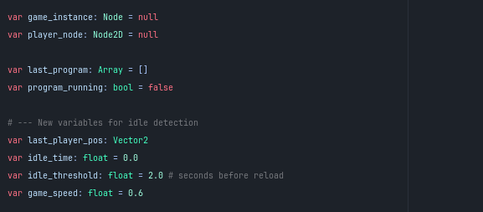

**Explanation:**

* **var game_instance: Node = null**: Holds the current game instance.
* **var player_node: Node2D = null**: References the player node.
* **var last_program: Array = []**: Stores the last program executed.
* **var program_running: bool = false**: Tracks whether a program is currently running.
* **Idle detection variables**:
  + **var last_player_pos: Vector2**: Stores the last position of the player.
  + **var idle_time: float = 0.0**: Tracks idle time.
  + **var idle_threshold: float = 2.0**: Sets the threshold for idle time before reloading.
  + **var game_speed: float = 0.6**: Sets the speed for game actions.

### 6.8.4 Function: _ready

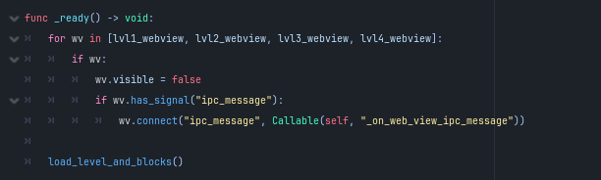

**Explanation:**

* **func _ready() -> void:**: Called when the node is added to the scene.
  + **Hides web views**: Sets all web views to invisible and connects their signals to handle IPC messages.
  + **Loads level and blocks**: Calls load_level_and_blocks() to initialize the game.

### 6.8.5 Function: _process

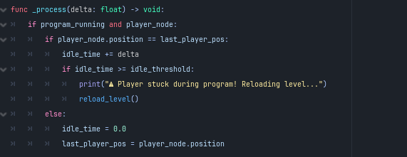

**Explanation:**

* **func _process(delta: float) -> void:**: Called every frame to update the state.
  + **Idle detection**: Checks if the player is stuck and reloads the level if idle time exceeds the threshold.

### 6.8.6 Function: go_back

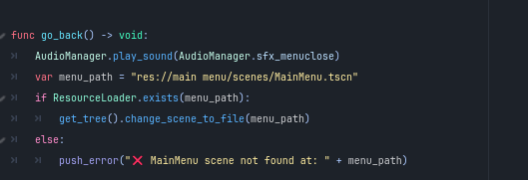

**Explanation:**

* **func go_back() -> void:**: Handles navigating back to the main menu.
  + **Plays sound**: Triggers a sound effect for closing the menu.
  + **Changes scene**: Loads the main menu scene if it exists.

### 6.8.7 Function: load_game

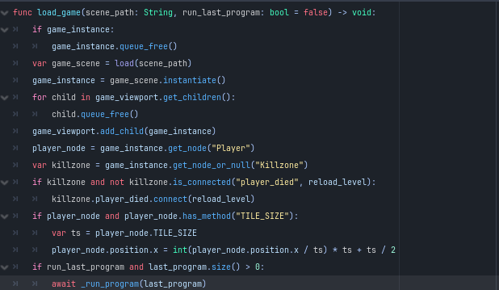

**Explanation**

* **func load_game(scene_path: String, run_last_program: bool = false) -> void:**: Loads a game scene from the specified path.
  + **Cleans up existing instances**: Frees the previous game instance if it exists.
  + **Instantiates the new game scene**: Loads and adds the new game instance to the viewport.
  + **Sets player node reference**: Retrieves the player node from the new instance.
  + **Connects killzone signal**: Ensures the killzone is wired to reload the level on player death.
  + **Positions player correctly**: Aligns the player to the nearest tile.
  + **Runs last program if applicable**: Executes the last program if specified.

### 6.8.8 Function: reload_level

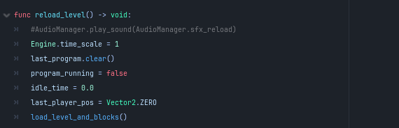

**Explanation:**

* **func reload_level() -> void:**: Reloads the current level.
  + **Resets game state**: Clears the last program and resets variables.
  + **Loads level and blocks**: Calls load_level_and_blocks() to refresh the game.

### 6.8.9 Function: _on_web_view_ipc_message

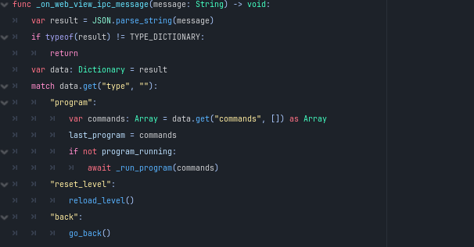

**Explanation:**

* **func _on_web_view_ipc_message(message: String) -> void:**: Handles IPC messages from the web view.
  + **Parses message**: Converts the JSON string into a dictionary.
  + **Executes commands based on message type**: Processes program commands, resets level, or navigates back.

### 6.8.10 Function: _run_program

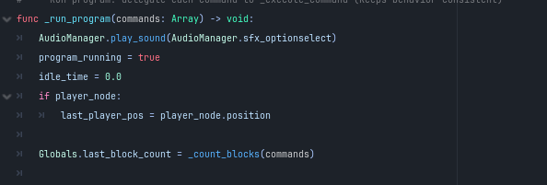

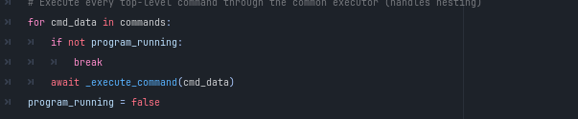

**Explanation:**

* **func _run_program(commands: Array) -> void:**: Executes a series of commands.
  + **Plays selection sound**: Triggers a sound effect when starting the program.
  + **Tracks player position**: Saves the current player position for idle detection.
  + **Counts blocks**: Updates the block count in global variables.
  + **Executes each command**: Iterates through commands and calls _execute_command().

### 6.8.11 Function: _execute_command

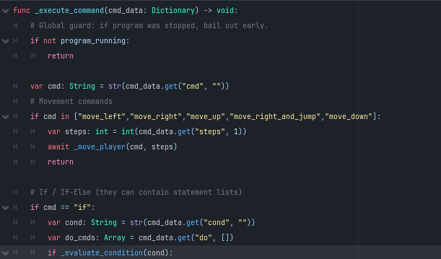

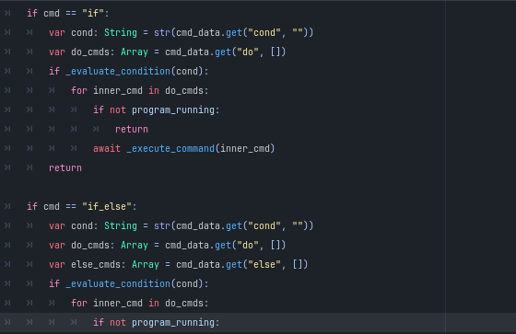

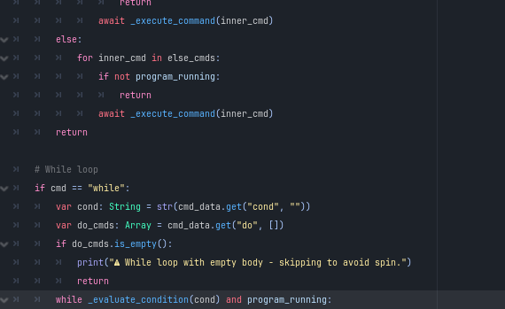

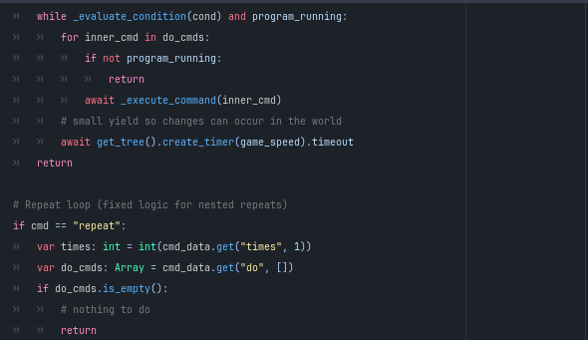

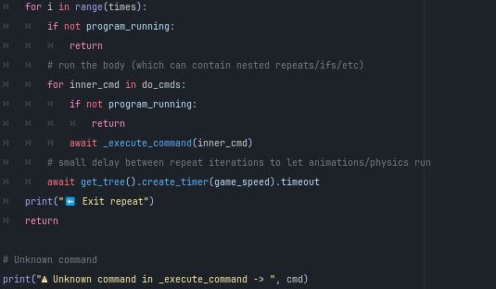

**Explanation:**

* **func _execute_command(cmd_data: Dictionary) -> void:**: Executes a single command.
  + **Checks if the program is still running**: Exits early if the program has been stopped.
  + **Handles movement commands**: Executes player movement based on the command.
  + **Handles conditional commands**: Processes if, if_else, and while commands with nested execution.
  + **Handles repeat loops**: Executes commands a specified number of times.
  + **Logs unknown commands**: Prints a warning message for unrecognized commands.

### 6.8.12 Function: _evaluate_condition

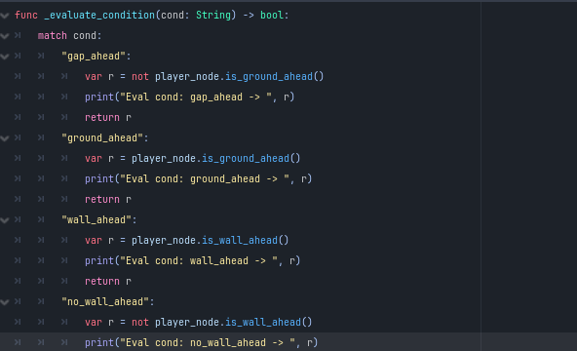

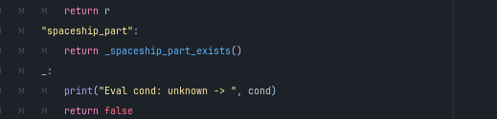

**Explanation:**

* **func _evaluate_condition(cond: String) -> bool:**: Evaluates a condition for commands.
  + **Checks various conditions**: Determines the state of the player (e.g., whether there's ground or a wall ahead)

### 6.8.13 Function: _move_player

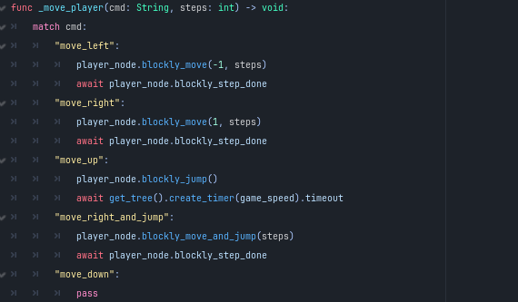

**Explanation:**

* **func _move_player(cmd: String, steps: int) -> void:**: Moves the player based on the command.
  + **Handles different movement types**: Calls the appropriate movement method on the player node.

### 6.8.14 Function: _spaceship_part_exists

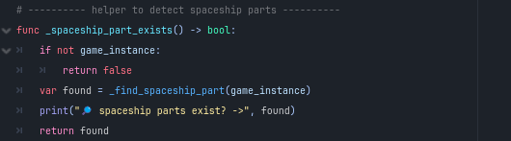

* **func _spaceship_part_exists() -> bool:**: Checks if spaceship parts exist in the game instance.
  + **Calls a recursive search function**: Uses _find_spaceship_part() to check the node hierarchy.

### 6.8.15 Function: _find_spaceship_part

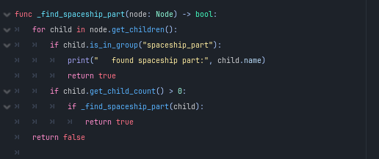

**Explanation:**

* **func _find_spaceship_part(node: Node) -> bool:**: Recursively searches for spaceship parts in the node tree.
  + **Logs found parts**: Prints the name of any found spaceship parts.

### 6.8.16 Function: _count_blocks

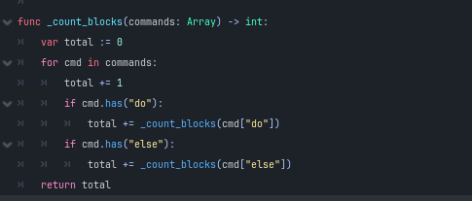

**Explanation:**

* **func _count_blocks(commands: Array) -> int:**: Counts the number of commands in a program.
  + **Recursively counts commands**: Accounts for nested commands as well.

## Coin.gd

### 6.8.17 Class: Spaceship Part Script



**Explanation:**

* **extends Area2D**: The script extends the Area2D class for 2D area functionality.

### 6.8.18 Nodes

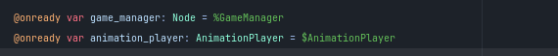

**Explanation:**

* **@onready var game_manager: Node = %GameManager**: References the Game Manager node.
* **@onready var animation_player: AnimationPlayer = $AnimationPlayer**: References the AnimationPlayer for handling animations.

### 6.8.19 Variables

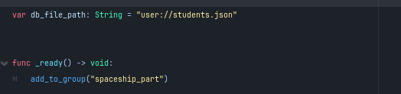

**Explanation:**

* **var db_file_path: String = "user://students.json"**: Specifies the path to the JSON file for student data.

### 6.8.20 Function: _ready

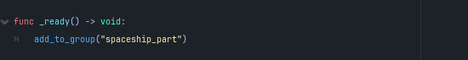

**Explanation:**

* **func _ready() -> void:**: Called when the node is added to the scene.
  + **Adds to group**: Puts this node into the "spaceship_part" group for identification.

### 6.8.21 Function: _on_body_entered

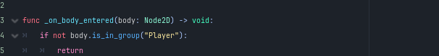

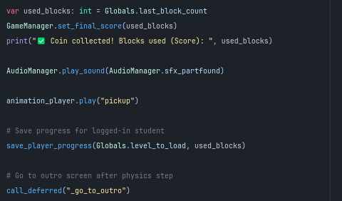

**Explanation:**

* **func _on_body_entered(body: Node2D) -> void:**: Called when another body enters the area.
  + **Checks for player**: If the entering body is not in the "Player" group, it exits.
  + **Score handling**:
    - Retrieves the last block count from globals and sets it as the final score.
    - Plays a sound effect for collecting the part.
    - Triggers the pickup animation.
    - Calls save_player_progress() to save progress for the logged-in student.
    - Defers the call to _go_to_outro() to change the scene after the physics step.

### 6.8.22 Function: _go_to_outro

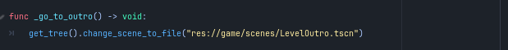

**Explanation:**

* **func _go_to_outro() -> void:**: Changes the scene to the outro screen.
  + **Scene change**: Loads the outro scene.

### 6.8.23 Function: save_player_progress

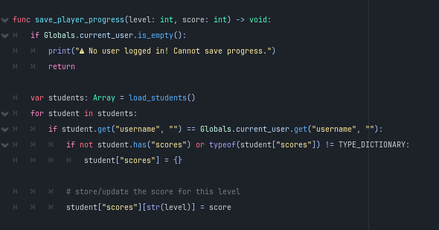

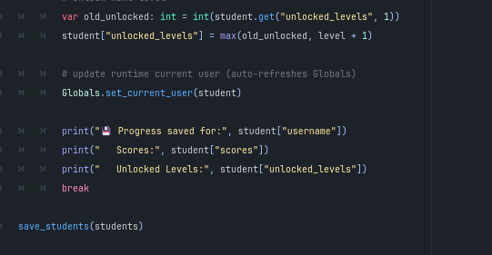

**Explanation:**

* **func save_player_progress(level: int, score: int) -> void:**: Saves the player's progress in the database.
  + **Checks for logged-in user**: Exits if no user is logged in.
  + **Loads student data**: Calls load_students() to retrieve the list of students.
  + **Updates score**: Finds the current user and updates their score for the specified level.
  + **Unlocks next level**: Increments the unlocked levels if necessary.
  + **Updates global user**: Calls Globals.set_current_user() to refresh the current user data.
  + **Logs progress**: Prints messages confirming the save operation.

### 6.8.24 Function: load_students

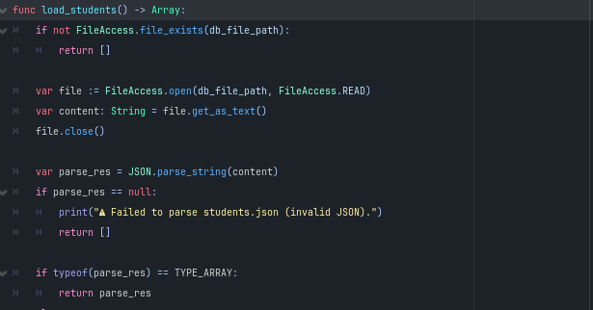

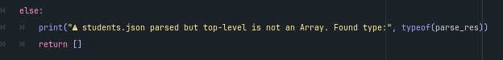

**Explanation:**

* **func load_students() -> Array:**: Loads student data from the JSON file.
  + **File existence check**: Returns an empty array if the file does not exist.
  + **Reads file content**: Opens the file and retrieves its contents as a string.
  + **Parses JSON**: Converts the text content into a variant.
  + **Validation**: Checks if the parsed result is an array; returns an empty array if not.

### 6.8.25 Function: save_students

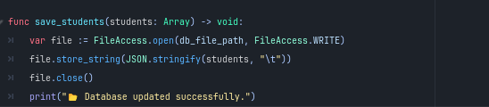

**Explanation:**

* **func save_students(students: Array) -> void:**: Saves the student data back to the JSON file.
  + **Opens file for writing**: Writes the data as a formatted JSON string.
  + **Logs success**: Prints a message confirming that the database was updated successfully.

## **Player**.gd

### 6.8.26 Class: Player Character Script



**Explanation:**

* **extends CharacterBody2D**: The script extends the CharacterBody2D class for character control in 2D space.

### 6.8.27 Constants

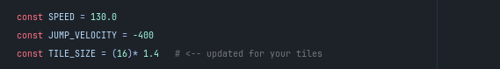

**Explanation:**

* **const SPEED = 130.0**: Sets the movement speed of the player.
* **const JUMP_VELOCITY = -400**: Defines the velocity of the player when jumping.
* **const TILE_SIZE = (16) * 1.4**: Sets the size of the tiles, updated for the game's scale.

### 6.8.28 Nodes



**Explanation:**

* **@onready var animated_sprite: AnimatedSprite2D = $AnimatedSprite2D**: References the AnimatedSprite2D for character animations.

### 6.8.29 Variables

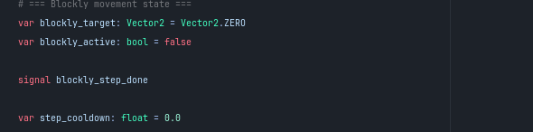

**Explanation:**

* **var blockly_target: Vector2 = Vector2.ZERO**: Stores the target position for Blockly commands.
* **var blockly_active: bool = false**: Tracks whether Blockly movement is active.
* **signal blockly_step_done**: Signal emitted when a Blockly movement step is completed.
* **var step_cooldown: float = 0.0**: Cooldown timer for step sounds.

### 6.8.30 Function: _play_step_sound

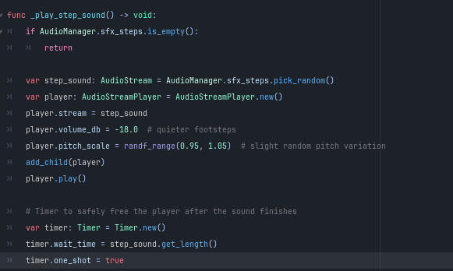

**Explanation:**

* **func _play_step_sound() -> void:**: Plays a sound for the player's footsteps.
  + **Checks for sounds**: Returns if no step sounds are available.
  + **Creates a new audio player**: Plays a random step sound with a slight pitch variation.
  + **Sets up a timer**: Frees the audio player after the sound finishes.

### 6.8.31 Function: _on_step_sound_finished

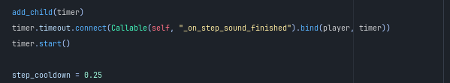

**Explanation:**

* **func _on_step_sound_finished(player: AudioStreamPlayer, timer: Timer) -> void:**: Cleans up after the step sound finishes playing.
  + **Checks validity**: Frees the audio player and timer if they are still valid.

### 6.8.32 Blockly API Functions

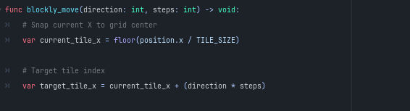

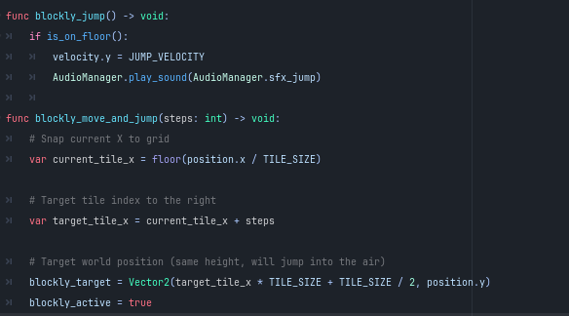

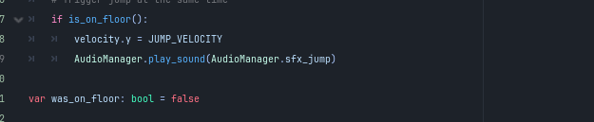

**Explanation:**

* **func blockly_move(direction: int, steps: int) -> void:**: Moves the player in a specified direction by a number of steps.
  + **Calculates target position**: Sets the target position based on the current tile and direction.
* **func blockly_jump() -> void:**: Makes the player jump if they are on the floor.
  + **Sets jump velocity**: Updates the vertical velocity and plays a jump sound.
* **func blockly_move_and_jump(steps: int) -> void:**: Moves the player and triggers a jump simultaneously.
  + **Calculates target position**: Similar to blockly_move, but triggers a jump if on the floor.

### 6.8.33 Function: Physics Process

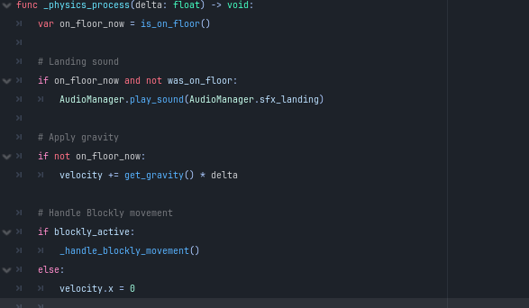

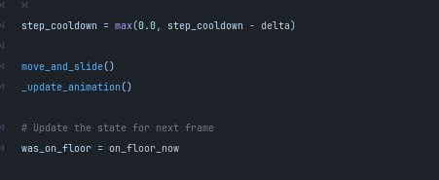

**Explanation:**

* **func _physics_process(delta: float) -> void:**: Called every frame for physics updates.
  + **Landing sound**: Plays a landing sound when the player lands.
  + **Applies gravity**: Adds gravity to the player if they are not on the floor.
  + **Handles Blockly movement**: Calls _handle_blockly_movement() if active, otherwise stops horizontal movement.
  + **Updates step cooldown**: Reduces the cooldown timer for playing footstep sounds.
  + **Moves the player**: Calls move_and_slide() for physics-based movement.
  + **Updates animations**: Calls _update_animation() to handle character animations.
  + **Tracks floor state**: Updates whether the player is on the floor for the next frame.

### 6.8.34 Blockly Movement Handler

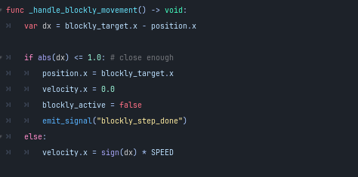

**Explanation:**

* **func _handle_blockly_movement() -> void:**: Manages the movement when Blockly commands are active.
  + **Checks proximity to target**: If close to the target, snaps to it and emits a signal.
  + **Updates velocity**: Moves towards the target if not close enough.

### 6.8.35 Animation Function

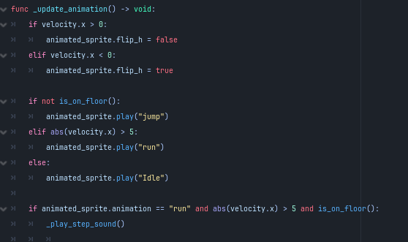

**Explanation:**

* **func _update_animation() -> void:**: Updates the player's animation state based on movement.
  + **Flips sprite**: Flips the animated sprite based on movement direction.
  + **Plays appropriate animations**: Chooses between "jump," "run," or "idle" based on state.
  + **Plays footstep sound**: Triggers the step sound if running.

### 6.8.36 Ground and Wall Detection

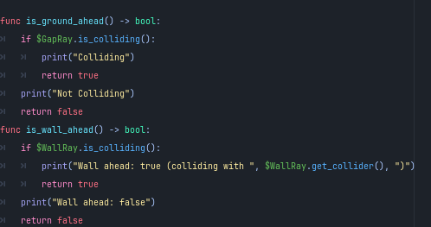

**Explanation:**

* **func is_ground_ahead() -> bool:**: Checks if there is ground ahead using a raycast.
  + **Returns collision status**: Prints and returns whether the player is colliding with ground.
* **func is_wall_ahead() -> bool:**: Checks if there is a wall ahead using a raycast.
  + **Returns collision status**: Prints and returns whether the player is colliding with a wall.

## Globals.gd

### 6.8.36 Class: Globals Script



**Explanation:**

* **extends Node**: The script extends the Node class for a general-purpose singleton.

### 6.8.37 Variables

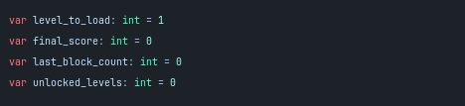

**Explanation:**

* **var level_to_load: int = 1**: Specifies the level currently set to load.
* **var final_score: int = 0**: Stores the final score for the current session.
* **var last_block_count: int = 0**: Records the number of blocks used in the last level.
* **var unlocked_levels: int = 0**: Tracks how many levels have been unlocked.
* **var current_user: Dictionary = {}**: Holds the data for the currently logged-in user.

### 6.8.38 Onready Variables

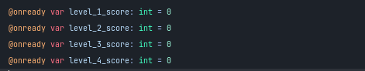

**Explanation:**

* **@onready var level_1_score: int = 0**: Score for Level 1, initialized when ready.
* **@onready var level_2_score: int = 0**: Score for Level 2, initialized when ready.
* **@onready var level_3_score: int = 0**: Score for Level 3, initialized when ready.
* **@onready var level_4_score: int = 0**: Score for Level 4, initialized when ready.

### 6.8.39 Function: set_current_user

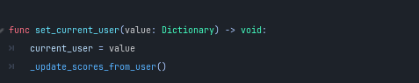

**Explanation:**

* **func set_current_user(value: Dictionary) -> void:**: Sets the current user and updates scores.
  + **Updates user data**: Assigns the provided dictionary to current_user.
  + **Calls score update**: Invokes _update_scores_from_user() to refresh scores.

### 6.8.40 Function: get_current_user

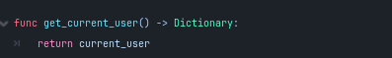

**Explanation:**

* **func get_current_user() -> Dictionary:**: Returns the current user's data.
  + **Returns user dictionary**: Provides access to the current_user variable.

### 6.8.41 Function: _update_scores_from_user

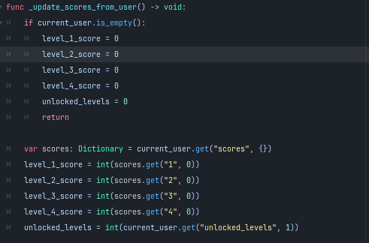

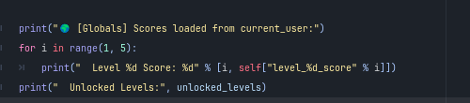

**Explanation:**

* **func _update_scores_from_user() -> void:**: Updates score variables based on the current user data.
  + **Checks for empty user**: Resets scores and unlocked levels if no user is logged in.
  + **Loads scores**: Retrieves scores from the user's data dictionary.
  + **Updates score variables**: Sets the score variables for each level and the number of unlocked levels.
  + **Logs scores**: Prints the loaded scores and unlocked levels to the console for debugging.

## 6.9 Main Menu

### 6.9.1 Class: Level Selection Menu Script



**Explanation**

* **extends Control**: The script extends the Control class for UI elements.

### 6.9.2 Nodes

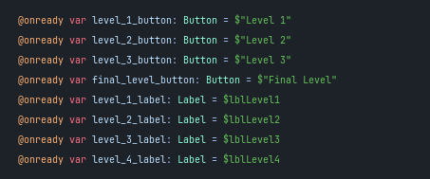

**Explanation:**

* **@onready var level_1_button: Button = $"Level 1"**: References the button for Level 1.
* **@onready var level_2_button: Button = $"Level 2"**: References the button for Level 2.
* **@onready var level_3_button: Button = $"Level 3"**: References the button for Level 3.
* **@onready var final_level_button: Button = $"Final Level"**: References the button for the final level.
* **@onready var level_1_label: Label = $lblLevel1**: References the label for displaying Level 1 score.
* **@onready var level_2_label: Label = $lblLevel2**: References the label for displaying Level 2 score.
* **@onready var level_3_label: Label = $lblLevel3**: References the label for displaying Level 3 score.
* **@onready var level_4_label: Label = $lblLevel4**: References the label for displaying Level 4 score.

### 6.9.3 Function: _ready

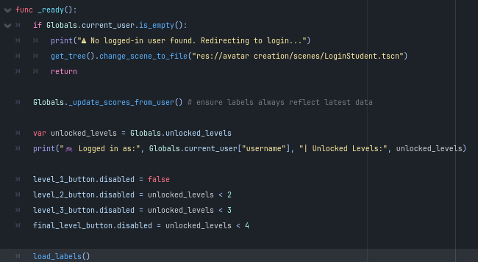

**Explanation:**

* **func _ready():**: Called when the node is added to the scene.
  + **Checks for logged-in user**: Redirects to the login scene if no user is logged in.
  + **Updates scores**: Calls Globals._update_scores_from_user() to refresh scores.
  + **Logs user info**: Prints the username and the number of unlocked levels.
  + **Enables/disables level buttons**: Sets button states based on the number of unlocked levels.
  + **Loads score labels**: Calls load_labels() to update the displayed scores.

### 6.9.4 Function: load_labels

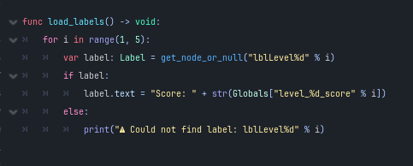

**Explanation:**

* **func load_labels() -> void:**: Updates the labels with the current scores for each level.
  + **Iterates through levels**: Loops from 1 to 4 to find and update each label.
  + **Handles missing labels**: Prints a warning if a label cannot be found.

### 6.9.5 Level Button Functions

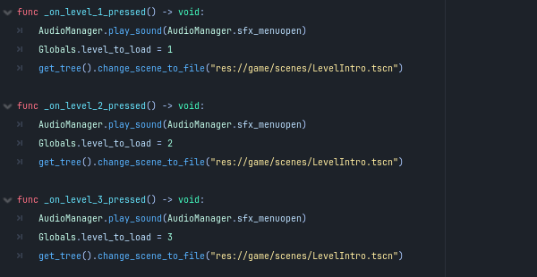

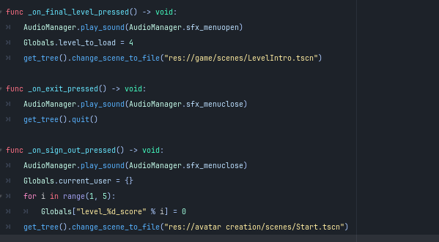

**Explanation:**

* **func _on_level_1_pressed() -> void:**: Handles the Level 1 button press.
  + **Plays sound effect**: Triggers the menu open sound.
  + **Sets level to load**: Updates Globals.level_to_load to 1.
  + **Changes scene**: Loads the Level Intro scene.
* **func _on_level_2_pressed() -> void:**: Handles the Level 2 button press.
  + **Plays sound effect**: Triggers the menu open sound.
  + **Sets level to load**: Updates Globals.level_to_load to 2.
  + **Changes scene**: Loads the Level Intro scene.
* **func _on_level_3_pressed() -> void:**: Handles the Level 3 button press.
  + **Plays sound effect**: Triggers the menu open sound.
  + **Sets level to load**: Updates Globals.level_to_load to 3.
  + **Changes scene**: Loads the Level Intro scene.
* **func _on_final_level_pressed() -> void:**: Handles the Final Level button press.
  + **Plays sound effect**: Triggers the menu open sound.
  + **Sets level to load**: Updates Globals.level_to_load to 4.
  + **Changes scene**: Loads the Level Intro scene.

### 6.9.6 Exit and Sign-Out Functions

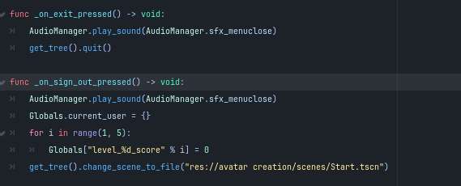

**Explanation:**

* **func _on_exit_pressed() -> void:**: Handles the exit button press.
  + **Plays sound effect**: Triggers the menu close sound.
  + **Quits the application**: Calls get_tree().quit() to exit.
* **func _on_sign_out_pressed() -> void:**: Handles the sign-out button press.
  + **Plays sound effect**: Triggers the menu close sound.
  + **Resets current user**: Clears the current_user data.
  + **Resets scores**: Sets all level scores to 0.
  + **Changes scene**: Loads the Start scene for avatar creation.

## 6.10 Student Management

### 6.10.1 Class: Level Selection Menu Script



**Explanation:**

* **extends Control**: The script extends the Control class, which is used for UI elements.

### 6.10.2 Nodes

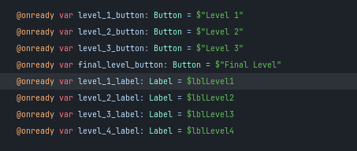

**Explanation:**

* **@onready var level_1_button: Button = $"Level 1"**: References the button for Level 1.
* **@onready var level_2_button: Button = $"Level 2"**: References the button for Level 2.
* **@onready var level_3_button: Button = $"Level 3"**: References the button for Level 3.
* **@onready var final_level_button: Button = $"Final Level"**: References the button for the final level.
* **@onready var level_1_label: Label = $lblLevel1**: References the label for displaying Level 1 score.
* **@onready var level_2_label: Label = $lblLevel2**: References the label for displaying Level 2 score.
* **@onready var level_3_label: Label = $lblLevel3**: References the label for displaying Level 3 score.
* **@onready var level_4_label: Label = $lblLevel4**: References the label for displaying Level 4 score.

### 6.10.3 Function: _ready

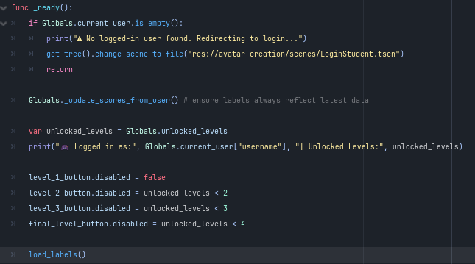

**Explanation:**

* **func _ready():**: Called when the node is added to the scene.
  + **Checks for logged-in user**: Redirects to the login scene if no user is logged in and prints a warning message.
  + **Updates scores**: Calls Globals._update_scores_from_user() to refresh the displayed scores.
  + **Logs user info**: Prints the username and the number of unlocked levels to the console.
  + **Enables/disables level buttons**: Sets button states based on the number of unlocked levels.
  + **Loads score labels**: Calls load_labels() to update the displayed scores for each level.

### 6.10.4 Function: load_labels

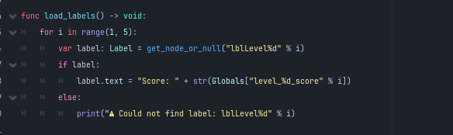

**Explanation:**

* **func load_labels() -> void:**: Updates the labels with the current scores for each level.
  + **Iterates through levels**: Loops from 1 to 4 to find and update each label.
  + **Handles missing labels**: Prints a warning if a label cannot be found.

### 6.10.5 Level Button Functions

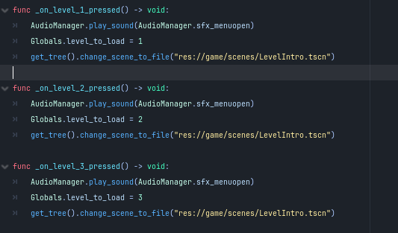

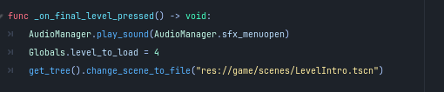

**Explanation:**

* **func _on_level_1_pressed() -> void:**: Handles the Level 1 button press.
  + **Plays sound effect**: Triggers the menu open sound effect.
  + **Sets level to load**: Updates Globals.level_to_load to 1.
  + **Changes scene**: Loads the Level Intro scene.
* **func _on_level_2_pressed() -> void:**: Handles the Level 2 button press.
  + **Plays sound effect**: Triggers the menu open sound effect.
  + **Sets level to load**: Updates Globals.level_to_load to 2.
  + **Changes scene**: Loads the Level Intro scene.
* **func _on_level_3_pressed() -> void:**: Handles the Level 3 button press.
  + **Plays sound effect**: Triggers the menu open sound effect.
  + **Sets level to load**: Updates Globals.level_to_load to 3.
  + **Changes scene**: Loads the Level Intro scene.
* **func _on_final_level_pressed() -> void:**: Handles the Final Level button press.
  + **Plays sound effect**: Triggers the menu open sound effect.
  + **Sets level to load**: Updates Globals.level_to_load to 4.
  + **Changes scene**: Loads the Level Intro scene.

### 6.10.6 Exit and Sign-Out Functions

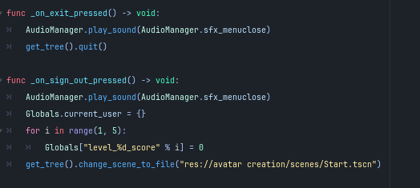

**Explanation:**

* **func _on_exit_pressed() -> void:**: Handles the exit button press.
  + **Plays sound effect**: Triggers the menu close sound effect.
  + **Quits the application**: Calls get_tree().quit() to exit the game.
* **func _on_sign_out_pressed() -> void:**: Handles the sign-out button press.
  + **Plays sound effect**: Triggers the menu close sound effect.
  + **Resets current user**: Clears the current_user data.
  + **Resets scores**: Sets all level scores to 0.
  + **Changes scene**: Loads the Start scene for avatar creation.

## 6.11 Audio.gd

### 6.11.1 Class: AudioManager Script



**Explanation:**

* **extends Node**: The script extends the Node class to manage audio in the game.

### 6.11.2 Sound Effects

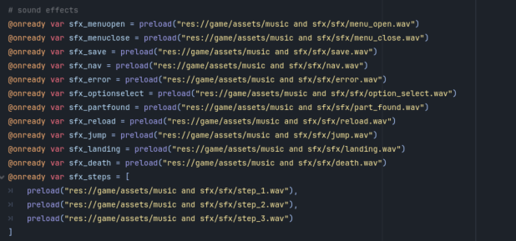

**Explanation:**

* **Preloading Sound Effects**: Various sound effects are preloaded for efficient use throughout the game, including:
  + **Menu Sounds**: sfx_menuopen, sfx_menuclose, sfx_optionselect.
  + **Gameplay Sounds**: sfx_jump, sfx_landing, sfx_death, and others.
  + **Step Sounds**: An array of step sounds (sfx_steps) for character movement.

### 6.11.3 Background Music

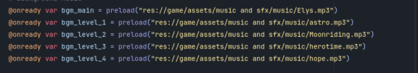

**Explanation:**

* **Preloading Background Music**: Several background music tracks are preloaded for different game contexts, such as:
  + **Main Menu Music**: bgm_main.
  + **Level Music**: Separate tracks for each level (bgm_level_1, bgm_level_2, etc.).

### 6.11.4 Variables

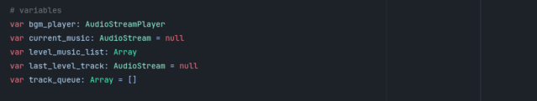

**Explanation:**

* **Audio Stream Management**:
  + **bgm_player**: An instance of AudioStreamPlayer for playing background music.
  + **current_music**: Tracks the currently playing music stream.
  + **level_music_list**: An array holding music tracks for each level.
  + **track_queue**: An array for managing music track randomness.

### 6.11.5 Function: _ready

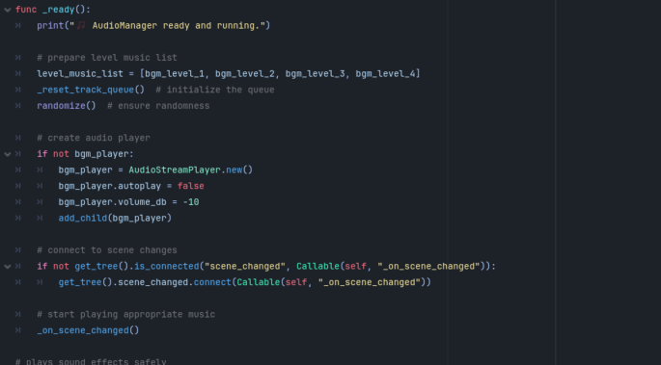

**Explanation:**

* **func _ready():**: Called when the node is added to the scene.
  + **Initial Setup**: Prepares the level music list and initializes the track queue.
  + **Creates Audio Player**: Instantiates bgm_player if it doesn't exist and sets its properties.
  + **Connects Scene Changes**: Connects the scene change signal to handle music transitions and starts playing the appropriate music.

### 6.11.6 Function: play_sound

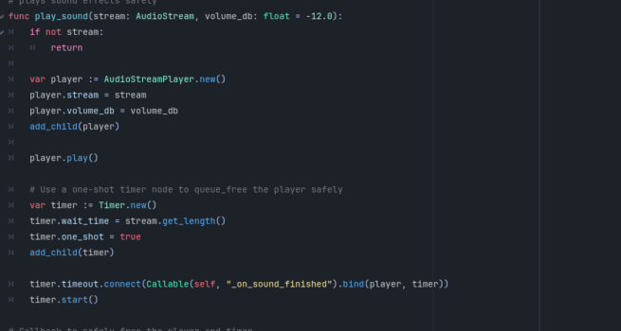

**Explanation:**

* **func play_sound(stream: AudioStream, volume_db: float = -12.0):**: Plays sound effects safely.
  + **Creates a new audio player**: Instantiates AudioStreamPlayer for the sound effect.
  + **Sets up a timer**: Uses a timer to free the player after the sound finishes playing.

### 6.11.7 Function: _on_sound_finished

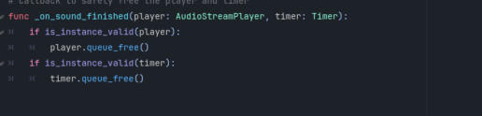

**Explanation:**

* **func _on_sound_finished(player: AudioStreamPlayer, timer: Timer):**: Cleans up after a sound effect finishes playing.
  + **Checks validity**: Safely frees the audio player and timer if they are still valid.

### 6.11.8 Function: play_music

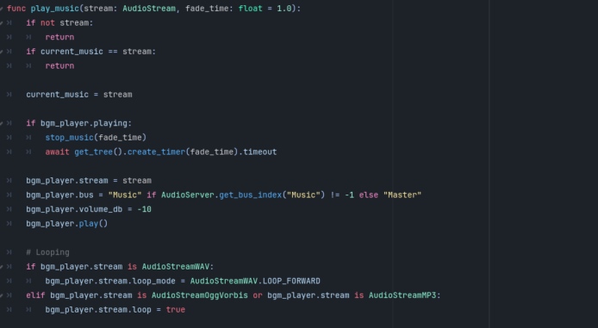

**Explanation:**

* **func play_music(stream: AudioStream, fade_time: float = 1.0):**: Plays background music.
  + **Checks for existing stream**: Prevents reloading the same track.
  + **Handles fading**: Stops current music with a fade-out effect before starting the new track.
  + **Sets looping**: Configures the music stream to loop appropriately based on its type.

### 6.11.9 Function: stop_music

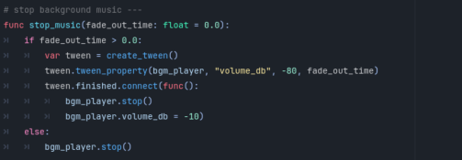

**Explanation:**

* **func stop_music(fade_out_time: float = 0.0):**: Stops the background music.
  + **Handles fade-out**: Uses a tween to gradually lower the volume before stopping the music.

### 6.11.10 Function: _on_scene_changed

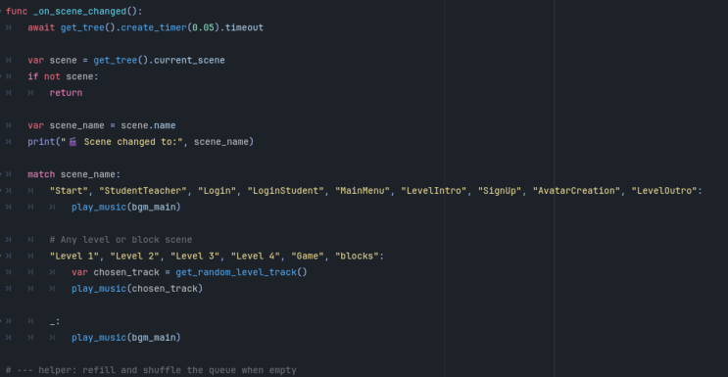

**Explanation:**

* **func _on_scene_changed():**: Handles changes to the current scene.
  + **Determines the current scene**: Checks the scene name and plays appropriate music based on it.
  + **Default music**: Plays main menu music for non-level scenes and random level music for gameplay scenes.

### 6.11.11 Function: _reset_track_queue

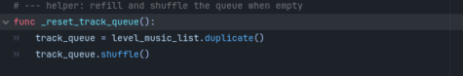

**Explanation:**

* **func _reset_track_queue():**: Resets and shuffles the track queue when it is empty.

### 6.11.12 Function: get_random_level_track

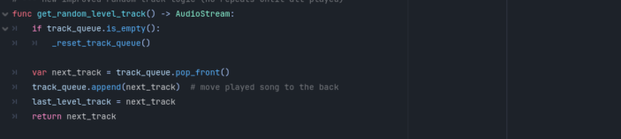

**Explanation:**

* **func get_random_level_track() -> AudioStream:**: Retrieves a random level track without repeats until all tracks have played.
  + **Checks track queue**: Resets the queue if it’s empty and returns the next track while ensuring it is not repeated too soon.